Arab Open University- Bahrain



Faculty of Computer Studies
Information Technology and Computing Department

Blood Bank Bahrain (BBB)

Yusuf Abdulrahman Shareeda & 6200569
TM471: Final Year Project, April 2024
Supervisor: Dr. Asdaque & Dr. Meera

Abstract
The goal of this project is to create a blood management information system that would help with blood donor record maintenance and facilitate and/or regulate the distribution of blood around the nation based on hospital needs. It is extremely difficult to develop market strategies for blood donation, lobby, and blood donor sensitization without prompt and easy access to donor records. The blood management information system provides features that enable easy access to donor records that are gathered across the nation. It makes it possible to track the effectiveness and outcomes of the blood donation campaign so that the organization's pertinent and quantifiable goals can be verified. It gives management access to fast, private, and secure medical reports, which helps with planning and decision-making and, ultimately, improves the provision of medical services. Most of the questions management about blood donor records are addressed by the reports produced by the system.

Acknowledgment
I want to express my sincere gratitude to Dr. Asdaque and Kananah, my supervisors, for all their help and support during this research. Their knowledge has been crucial to its accomplishment.
I am appreciative of my family's unwavering understanding and support. Their support helped me stay inspired. I also appreciate the insightful comments and advice from my friends and coworkers. We especially thank Ghanem Al-Khalidi, a scholarship student studying medicine in Jordan, and I don’t forget Khalid Salmeen Bazqameh, HR assistant & has information system (IT) degree in King Khalid University, those whose helped made this effort possible.
Lastly, I want to thank my father for his unfailing confidence in me and support. His support has been a major motivator.

Content
Abstract i
Acknowledgment ii
Content iii
List of Figures vii
List of Tables viii
Chapter 1: Introduction 1
1.1. Introduction 1
1.2. Background of the study 1
1.3. Project Aims 4
1.4. Project Objectives 4
1.4.1. General objectives 4
1.4.2. Specific Objectives 4
1.5. Problem Definition 4
1.6. Suggested Solution 5
1.7. Targeted Customers or Beneficiaries 5
1.7.1. Guest: 5
1.7.2. User: 5
1.7.3. Hospital: 5
1.7.4. Admin: 5
1.8. Project Scope/Delimitation 5
1.9. Project Schedule 6
1.10. Summary of Chapter 1 7
Chapter 2: Literature Review 8
2.1. Introduction 8
2.2. Search Strategy used 8
2.3. Review of related literature 8
2.4. Summary of the literature review 8
2.5. Compare and contrast (features of the similar systems and proposed system) 9
2.5.1. Blood Donation - Ministry of Health (App & Website): 9
2.5.2. Bahrain Red Crescent Society (Website): 10
2.5.3. Bahrain Open Data Portal (Website): 10
Chapter 3: Requirements and Analysis 12
3.1. Introduction 12
3.2. Software Development model used 12
3.3. Requirement Elicitation 12
3.4. Functional Requirements 12
3.4.1. User Registration: 12
3.4.2. Donor Search and Matching: 12
3.4.3. Appointment Scheduling: 12
3.5. Non-Functional Requirements 12
3.5.1. Performance: 12
3.5.2. Security: 12
3.5.3. Technical Solution Requirements: 13
3.6. Software Requirement 13
3.6.1. Focus 13
3.6.2. Android Studio: 13
3.7. Hardware Requirements 13
3.8. Software modelling tools 13
3.9. Analysis diagram 13
3.9.1. Use case diagrams 13
3.9.5. Activity diagram 16
3.9.6. Entity Relationship diagram: 17
Chapter 4: Design, Implementation and testing 19
4.1. Introduction 19
4.2. The software development model used 19
4.3. Justification of the model selected 19
4.4. Advantage of the selected approach 19
4.5. Alternative model/ approach 20
4.6. Justification for not selecting the alternative approach 20
4.7. Database design 20
4.7.1. Mysql table: 21
4.7.2. Blood table: 21
4.7.3. Login table: 22
4.7.4. Stock table: 22
4.7.5. Hospital table: 22
4.7.6. Admin table: 23
4.8. User interface design: 23
4.8.1. Website: 23
4.8.2. Application: 24
4.9. Design Diagrams (flow chart diagram) 25
4.10. Implementation 26
4.10.1. Database: 26
4.10.2. Coding software: 27
4.10.3. Coding Language (HTML & CSS & PHP): 27
4.10.4. <Blood Bank Bahrain> implementation: 28
4.10.5. Database implementation: 28
4.10.6 Software implementation 32
4.11. Testing 47
4.11.1. Testing (solve android database): 48
4.11.2. Testing (adding ABO video & Ads to my website): 48
Chapter 5: Results and discussion 49
5.1. Findings 49
5.2. Goals achieved and unachieved goals 49
5.2.1. Goals achieved: 49
5.2.2. Unachieved goals 49
5.3. Future goals 50
5.2.1. A list of future work: 50
Chapter 6: Conclusions 51
6.1. Project Part A: Learning Skills 51
6.1.1. HTML and CSS: 51
6.1.2. Angular and JavaScript.js: 51
6.1.3. Bootstrap: 51
6.1.4. PHP and SQL: 51
6.1.5. Cordova: 51
6.2. Project Part B: Overcoming Personal Challenges 52
6.2. Collaborating with the Ministry of Health 52
6.3. The Legacy of Blood Bank Bahrain 52
6.4. A Journey of Growth and Gratitude 53
References 54

List of Figures
Figure 1.1: People who use internet in Bahrain 1
Figure 1.2: Blood types in Bahrain 2
Figure 1.3: Donor’s amount of the total population 3
Figure 2.1 Ministry of Health 9
Figure 2.2 Bahrain Red Crescent Society 10
Figure 2.3 Bahrain Open Data Portal 10
Figure 3.1 Use case diagram (User & Admin) 14
Figure 3.2 Use case diagram (Guest & Hospital) 15
Figure 3.3 Activity diagram 16
Figure 3.4 Entity Relationship diagram 18
Figure 4.1 Waterfall model 19
Figure 4.2 Agile model 20
Figure 4.3 Website interface 23
Figure 4.4 Application interface 24
Figure 4.5 Flowchart diagram 25
Figure 5.8 Database table (Add table) 29
Figure 4.6 Guest Main Page Website 33
Figure 4.7 Guest Main Page Application 33
Figure 4.8 User Login Page Website 34
Figure 4.9 User Login Page Application 34
Figure 4.10 User Main Page Website 35
Figure 4.11 User Main Page Application 35
Figure 4.12 User Donor Page Website 36
Figure 4.13 User Donor Page Application 36
Figure 4.14 User Blood Bank Details Website 37
Figure 4.15 User Blood Bank Details Application 37
Figure 4.16 User Add Donor Website 38
Figure 4.17 User Add Donor Application 38
Figure 4.18 User Edit Details Website 39
Figure 4.19 User Edit Details Application 39
Figure 4.20 User Edit Profile Website 40
Figure 4.21 User Edit Profile Application 40
Figure 4.22 Hospital Login Page Website 41
Figure 4.23 Hospital Login Page Application 41
Figure 4.24 Hospital Main Page Website 42
Figure 4.25 Hospital Main Page Application 42
Figure 4.26 Hospital Add Blood Bank Website 43
Figure 4.27 Hospital Add Blood Bank Application 43
Figure 4.28 Hospital Edit Details Website 44
Figure 4.29 Hospital Edit Details Application 44
Figure 4.30 Admin Main Page Website 45
Figure 4.31 Admin Main Page Application 45
Figure 4.32 Admin Donor's Report Website 46
Figure 4.33 Admin Donor's Report Application 46
Figure 4.44 Admin Hospitals Report Website 47
Figure 4.45 Admin Hospitals Report Application 47
Figure 4.46 Cordova testing 48
Figure 4.47 ABO System 48
Figure 5.1 IOS Compatibility (Future goal) 50
Figure 5.2 Adding Languages (Future goal) 50
Figure 5.3 Notification (Future goal) 50
Figure 6.1 A Future of Hope and Giving. 53

List of Tables
Table 1.1: Schedule of the project 6
Table 1.2 Project Gantt 7
Table 2.1 Comparison application & website 11
Table 4.1 Mysql table 21
Table 4.2 Blood table 21
Table 4.3 Login table 22
Table 4.4 Stock table 22
Table 4.5 Hospital table 22
Table 4.7 Admin table 23
Table 4.6 Algorithm table 28
Table 4.7 Database table 29
Table 4.9 Database table (Browse table) 30
Table 4.10 Database table (Search table) 30
Table 4.11 Database table (Insert table) 31
Table 4.12 Database table (Empty table) 32
Table 4.13 Database table (Drop table) 32

Chapter 1: Introduction

1.1. Introduction
To make blood donation and distribution more efficient, the Blood Bank Bahrain (BBB) in Bahrain has created a digital platform and mobile application. The goal of these digital technologies is to increase the accessibility and convenience of blood donation for both donors and recipients. Through the app, users can find donation sites in their area, make appointments, and get details on upcoming donation events. In a similar vein, these features are provided by the web platform in a browser-based style. The BBB program and web platform use effective sorting and filtering techniques to match donors and eligible recipients quickly, which guarantees timely blood supply distribution. All things considered, these computerized solutions mark major developments in the administration of blood donations, improving efficacy and efficiency and improving Bahraini healthcare results.

1.2. Background of the study
Through my study, I discovered recent statistics that the Kingdom of Bahrain ranks first in the world in the percentage of individuals who use the Internet at a rate of 100%, along with the Kingdom of Saudi Arabia and the United Arab Emirates, while the Gulf Cooperation Council countries in general topped the global ranking [1].

Figure 1.1: People who use internet in Bahrain

The following figure shows the percentage distribution of blood types in Bahrain [3].

Figure 1.2: Blood types in Bahrain
Through my research, the percentage of people who donate blood in Bahrain is, and you can also see Figure 1.4 for example:
If the number of populations in Bahrain is 1.463 million, and the number of blood donors in Bahrain is 19546.
To calculate the percentage of donors, we divide the number of donors by the population and then multiply the result by 100 to get the percentage.
Number of donors ÷ population x 100
= (19546 ÷ 1463000) x 100
= 0.01335 x 100
= 1.335%
Thus, the percentage of donors amounts to 1.335% of the total population, and this is a very small percentage in relation to the population [4].

Figure 1.3: Donor’s amount of the total population

1.3. Project Aims
- Improve Blood Bank Bahrain's services by making it more visible and accessible, making it easier to find donation locations, and facilitating information access.
- Include user-friendly features in the application and web portal to streamline donation procedures and increase donor involvement.
- Make efficient use of technology to match donors and recipients so that blood products are distributed in a timely and accurate manner.
- Enhance Blood Bank Bahrain's operational effectiveness by managing staff availability and scheduling as efficiently as possible.
- Encourage community involvement and dedication to blood donation by providing an approachable platform with the goal of saving lives.

1.4. Project Objectives
Developing an app and website that utilizes data input by teachers and students to assist in matching students with the most suitable teacher for them based on the data the student has provided.

1.4.1. General objectives
The principal objective is to streamline the blood donation and distribution procedures for Bahraini nationals when they obtain their driver's license. This includes helping people find appropriate blood donation locations as well as supporting blood bank employees in scheduling donation times and dates without requiring direct interaction.

1.4.2. Specific Objectives
The following needs and situations will be addressed by this initiative to improve the experience of giving blood:
- Considering the interests of female donors by offering ways to find donation locations and personnel that are friendly to women.
- Supplying new donors with an expedient way to locate donation locations nearby, guaranteeing a quick and easy procedure.
- Lowering the quantity of pointless phone calls needed to arrange appointments by putting in place a productive digital infrastructure for coordinating donations and recipients.

1.5. Problem Definition
Individuals will travel between hospitals to obtain blood, which can be time-consuming and occasionally unavailable. Sometimes the blood we receive from hospitals is insufficient, therefore we must look for another blood bank to get more blood. If an individual wishes to donate blood, they must visit the hospital, fill out a paperwork, and then wait for the doctor to verify their blood type before allowing them to donate. If a patient has an urgent need for blood, how would you find out about this condition? You might not even be able to get in touch with the patient.

1.6. Suggested Solution
The management information system of Blood Bank Bahrain (BBB) provides fast access to donor records gathered from around the nation. It makes it possible to track the effectiveness and outcomes of the blood donation campaign so that the organization's pertinent and quantifiable goals can be verified. It gives management access to fast, private, and secure medical reports, which helps with planning and decision-making and, ultimately, improves the provision of medical services. Most of the questions management has about blood donor records are addressed by the reports produced by the system.

1.7. Targeted Customers or Beneficiaries

1.7.1. Guest:
Guests are not required to provide any personal information to donate blood or add donors; they can only browse information about blood donors and available blood units.

1.7.2. User:
It is possible for users to register or log in, publish details about blood donors, examine information about donors and available blood units, and search for certain blood units or donors based on geography or blood type, all of which contribute to a quicker procedure.

1.7.3. Hospital:
Hospitals may efficiently manage and allocate blood by registering or logging in, posting details about their blood bank, updating blood group status, viewing information about blood donors and available blood units, and searching for specific donors or blood units.

1.7.4. Admin:
Admins can read all reports created by the system, download reports for additional analysis, and log in to obtain information on blood donors and available blood units. This allows for efficient oversight and strategic decision-making.

1.8. Project Scope/Delimitation
As table 1.1 illustrates, the project's goal is to create a comprehensive blood donation platform employing a variety of programming languages and tools, such as Notepad++, Visual Studio Code, and Android Studio. It utilizes XML, HTML, CSS, JavaScript, Node.js/TypeScript, and other technologies for broad functionality and cross-platform interoperability. Because of restrictions with Apple devices, the platform was initially limited to a website and an Android application. The XAMPP database connection enables easy data exchange and integration between the application and website, guaranteeing user accessibility on various platforms and devices and improving overall performance.

1.9. Project Schedule
Table 1.1: Schedule of the project
Stage | Steps | Aims | Date | Estimated duration
1 | Project concept | - Locating a project concept.  - Identifying a name. | From: 11/2/2024  To: 20/2/2024 | 16 Days
1 | Research | - Consult some Doctors.  - Find a project that shares the same concept. | From: 21/2/2024  To: 26/2/2024 | 16 Days
1 | Fundamentals | - Select the app's function that will be used. | From: 26/2/2024  To: 27/2/2024 | 16 Days
2 | The design's arrangement | - Develop the application's user interface and draw diagram of the app. | From: 29/2/2024  To: 6/3/2024 | 13 Days
2 | Database | - Build a database that satisfies design requirements. | From: 7/3/2024  To 13/3/2024 | 13 Days
3 | Coding | - Write the application's code. | From: 15/3/2024  To: 29/5/2024 | 139 Days
3 | Testing | - Test the code. | From: 30/5/2024  To: 11/6/2024 | 139 Days
3 | Troubleshooting | - Solve any error in the code. | From: 15/6/2024  To: 30/6/2024 | 139 Days
3 | App testing | - Test the application. | From: 6/7/2024  To: 14/7/2024 | 139 Days
3 | Debugging an app | - Solve any error in the application. | From: 20/7/2024  To: 1/8/2024 | 139 Days
4 | Presentation | - Present the application | From: 11/8/2024  To: 30/9/2024 | 50 Days

Project Gantt: You will be able to see all the times I mentioned previously along with the dates in this figure, and this includes writing the code, resolving errors, and submitting the project.
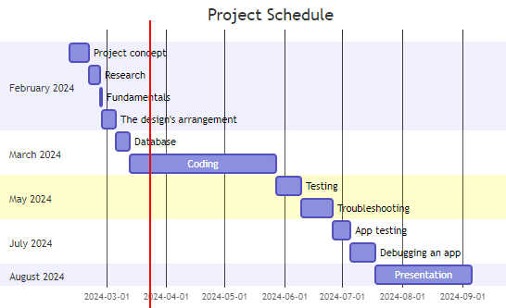
Table 1.2 Project Gantt

1.10. Summary of Chapter 1
The project's foundation is laid out in Chapter 1, which also outlines its primary goal of developing an all-inclusive blood donation platform. It provides an overview of the objectives, research questions, target audience, and statistical techniques. It also introduces programming languages and tools, such as Visual Studio Code, Android Studio, and Notepad++. The chapter explains the features of the platform—which includes a website and a mobile application—and argues for using them. Chapter 1 establishes the overall scope, objectives, and technology strategies for the project.

Chapter 2: Literature Review

2.1. Introduction
The project's journey starts with a thorough search to find the best features to add to the application and functions to integrate into it. These features are critical to improving the program's functioning. During this process, information was gathered using a variety of techniques, such as studying hospital reports pertaining to education and investigating apps with functionalities that could enhance the overall functionality and user experience of the app. These efforts yielded important insights that provided a solid basis for the project's later stages.

2.2. Search Strategy used
The initiative starts with an active data research method, which includes looking into healthcare applications and services, talking with scholarship recipients—especially doctors—and evaluating PDF files from universities. This mixed approach produces a large dataset that serves as the basis for the project's further development.

2.3. Review of related literature
While there is a similar effort at AOU University, it lacks aspects like hospital reports and donor information use, according to a literature analysis I completed for a blood bank project. The Blood Bank Bahrain website can be integrated with the My (BBB) app, which provides filtered donor lists that are stored in a database and makes manual donor adding easier, helping hospitals with paperwork.
The Bahrain blood bank does not currently have an app on the Google Play Store, despite Bahrain Services mentioning that one is in the early stages of development. Unlike previous apps, my program will improve search and filtering engines using data acquired from doctors, rather than simply copying what already exists.

2.4. Summary of the literature review
The project's literature review offers insightful information about the state of blood donation applications. The (BBB) app fills a void left by other programs' lack of interaction with hospital data and complete donor management features. A gap in fulfilling Bahrain's blood bank requirements is shown by analysis of alternative applications, underscoring the potential of the (BBB) app to provide customized solutions. The (BBB) app seeks to close these gaps to improve Bahrain's blood donation services' efficacy and accessibility.

2.5. Compare and contrast (features of the similar systems and proposed system)
I'll contrast my application and website with well-known ones, such the Bahrain Open Data Portal, the Ministry of Health, and the Bahrain Red Crescent Society. All the ones I listed have their logos displayed in Figures 2.1, 2.2, and 2.3.

2.5.1. Blood Donation - Ministry of Health (App & Website):
This web teaches you all the details of blood donation in Bahrain and contains information about all the hospitals where you can donate and contains donation appointments and how to book appointments for blood donation in Bahrain [5].

Figure 2.1 Ministry of Health

2.5.2. Bahrain Red Crescent Society (Website):
This association is for blood donation in Bahrain, and its benefit is booking appointments in hospitals, but its problem is that it is only a website and using it is difficult, and sometimes due to pressure, your donation request is not booked, and they do not send you a message via your phone number because the site does not use databases. It only books the appointment and sends it to the hospital [6]. 
Figure 2.2 Bahrain Red Crescent Society

2.5.3. Bahrain Open Data Portal (Website):
You can get all government information from this site, and one of its advantages is that it shows you the location of every government place, such as government hospitals and schools, and you can view all government appointments and news from this site, but its problem is that it does not show you private hospitals, as an admin you can print any appointment [7].

Figure 2.3 Bahrain Open Data Portal
My Blood Bank Bahrain application must have objectives that have the best searching and filtering fetchers, this I'll be using some of the greatest features from other well-known apps to perfect it.
1. Requires Registration: In line with Bahrain Red Crescent Society and Ministry of Health, your software necessitates account creation for users to fully utilize all of its features and content. If you just want to view, you will not need to log in to my Blood Bank Bahrain application unless you want to request or donate blood.
2. Category-Based Search: Your app has a category-based search feature that lets users navigate through different content categories or genres to find what they're interested in more quickly. This feature was inspired by Ministry of Health and Bahrain Open Data Portal. My Blood Bank Bahrain application will make you choose the category you want, whether donating or requesting blood.
3. Text-Based Search Bar: Text-Based Search Bar: Just like Ministry of Health and Bahrain Open Data Portal, your app has a search bar where users can enter specific terms or preferences to narrow down search results and browse further individually. This feature will be very useful in my Blood Bank Bahrain application, especially if you want to search for a specific hospital or place.
4. Creating report: Using the Bahrain Open Data Portal functionality as a model, your application/website offers to print all appointments as necessary. This feature will be present in the Bahrain Blood Bank application, and the admin will have the ability to downloading or printing at any time, and this also applies to previous blood donations if he wants to print them as well.
5. Admin Access: Like certain features on Ministry of Health, Bahrain Red Crescent Society and Bahrain Open Data Portal. your app may admin content or services for solving other problems in your app, granting admin users access to additional features or exclusive content upon. This thing will be in my Blood Bank Bahrain application as well, and they will have more features than the normal user.
Table 2.1 Comparison application & website
Properties | Ministry of Health | Bahrain Red Crescent Society | Bahrain Open Data Portal | My application
Requires Registration
Category-Based Search
Text-Based Search Bar
Creating report
Admin Access

Chapter 3: Requirements and Analysis

3.1. Introduction
To ensure that a project is completed correctly and has a desired outcome, it is necessary for it to adhere to guidelines and many requirements. Many requirements, including elicitation, functional nonfunctional, software, and hardware requirements, will be present in this application project.

3.2. Software Development model used
I employed the StarUML development paradigm for this project, which includes analysis, design, coding, and deployment.

3.3. Requirement Elicitation
To disclose assumed and concealed requirements during development and prevent conversion. To ensure smooth future design, development, and testing processes, this project should initially conduct requirement elicitation. Selected requirements for the project will include hardware, software, and non-functional requirements.

3.4. Functional Requirements

3.4.1. User Registration:
Users should be able to register on the blood bank app website by entering their name, contact information, and blood type, among other required personal data.

3.4.2. Donor Search and Matching:
Users should be able to look for blood donors using the app by entering parameters such blood type, location, and availability.
To ensure compatibility and prompt giving, the system should make it easier for donors and receivers to match.

3.4.3. Appointment Scheduling:
Through the app, users should be able to book appointments for blood donations, choosing convenient times and days.
Scheduled appointments should be reminded of contributors and beneficiaries via the system.

3.5. Non-Functional Requirements

3.5.1. Performance:
There should be no lag time or crashes when a lot of simultaneous user requests are handled by the blood bank app website. It should be responsive.

3.5.2. Security:
Future increases in the number of users and data volume should be supported by the system's capacity to dynamically scale resources as needed.

3.5.3. Technical Solution Requirements:
There should be smooth and thorough documentation of integration with external APIs, such as geolocation services for donor search and appointment scheduling services.

3.6. Software Requirement

3.6.1. Focus
Given the popularity of Android in Bahrain, our primary focus will be on building for the Android operating system and its related website. Developers on the Android platform can further simplify app testing and debugging by using XAMPP as the database.

3.6.2. Android Studio:
Despite its strength, Android Studio will only be utilized infrequently because of its high system requirements. The main development and playback platform for this project will be Visual Studio, which offers strong plugin support, device interoperability, and easy HTML integration. When it comes to application development, Android Studio is still a great option. It uses HTML, PHP, and XML to help developers construct cross-platform, high-quality apps [8].

3.7. Hardware Requirements
Since the software needs to connect to the database to obtain the information that the user has requested, this project requires a smartphone with an internet connection either over Wi-Fi or mobile data. Additionally, the program is compatible with any smartphone with any screen size, but it needs to be an Android phone or a computer for the website.

3.8. Software modelling tools
For the project, StarUML was used to produce exact and understandable diagrams because it provides an intuitive user interface and powerful visualization features.

3.9. Analysis diagram
In product development, UML, or Unified Modeling Language, is essential for defining, illustrating, and recording post-analysis systems. It helps create a model of the project entities that need to be built, which is important for designing representations that are used during the development of the product. Methodologies such as Use Case Diagrams, Sequence Diagrams, and Collaboration Diagrams are all parts of software design.

3.9.1. Use case diagrams
Use case diagrams assist developers in understanding user requirements by modeling system behavior. The term "actor" is represented by the stick figure. A case diagram can be helpful in providing an overview of the system and in defining the roles and responsibilities of each person.

User & Admin:
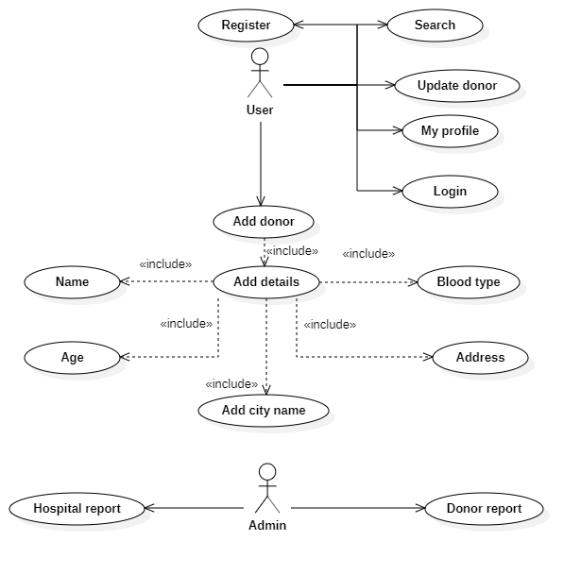
Figure 3.1 Use case diagram (User & Admin)

Guest & Hospital:
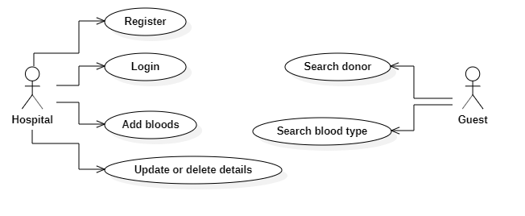
Figure 3.2 Use case diagram (Guest & Hospital)

3.9.5. Activity diagram
When you start the application, you have 4 actions.
- Guest:
If you select guest action, you will have more than one option(fork), either you can search for blood or view donor’s details.
- Admin:
If you select admin action, you can select one of two options(fork), either print hospitals report or print donor’s report.
- User:
If you select user action, you can choose all those actions:
- Register or login.
- Search donors.
- Search hospitals details.
- Or if you want to post you can select any of those(fork), post donation or update or delete donation information.
- Hospital:
If you select hospital action, you will have some similar actions as user:
- Register or login.
- Search donors.
- Search hospitals details.
- But the different action is to update or delete details.
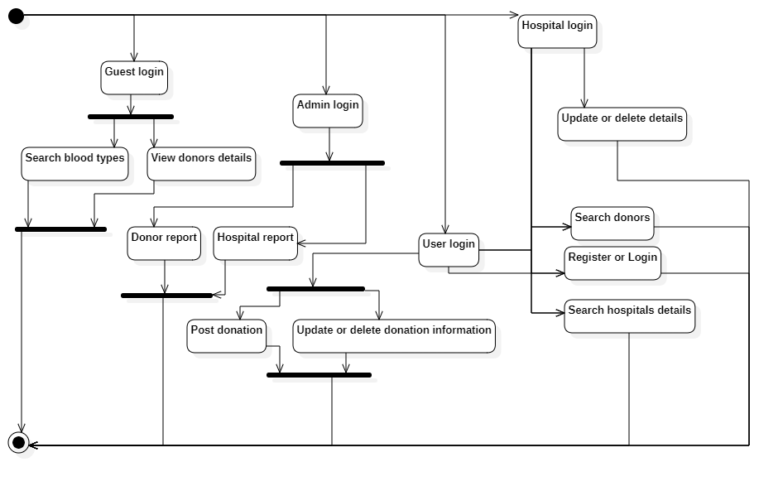
Figure 3.3 Activity diagram

3.9.6. Entity Relationship diagram:
Several tables containing Primary Keys (PK) and Foreign Keys (FK) make up the ERD. The explanation of each table is provided below:
1. `stock` Table (Primary Key: `stock_id`)
Columns: `email`, `hospital_name`, `mobile`, `town`, `created_date`
Purpose: Manages information about blood stock available at hospitals.
2. `login` Table (Primary Key: `user_id`)
Columns: `name`, `email`, `password`, `mobile`, `created_date`
Purpose: Stores user login information.
3. `blood` Table (Primary Key: `blood_id`)
Columns: `email`, `name`, `age`, `gender`, `address`, `mobile`, `town`, `status`, `created_date`
Purpose: Stores donor details such as contact info and availability.
4. `hospital_login` Table (Primary Key: `hopital_id`)
Columns: `hospital_name`, `email`, `password`, `mobile`, `created_date`
Purpose: Manages hospital login and account information.
5. `mysql` Table (Foreign Keys: `user_id`, `admin_id`, `hopital_id`, `blood_id`, `stock_id`)
Columns: `email`, `name`, `age`, `gender`, `address`, `mobile`, `town`, `status`, `created_date`, `password`
Purpose: Connects with all entities and serves as a central table to link data.
6. `admin_login` Table (Primary Key: `admin_id`)
Columns: `name`, `email`, `password`, `mobile`, `created_date`
Purpose: Stores admin login information.
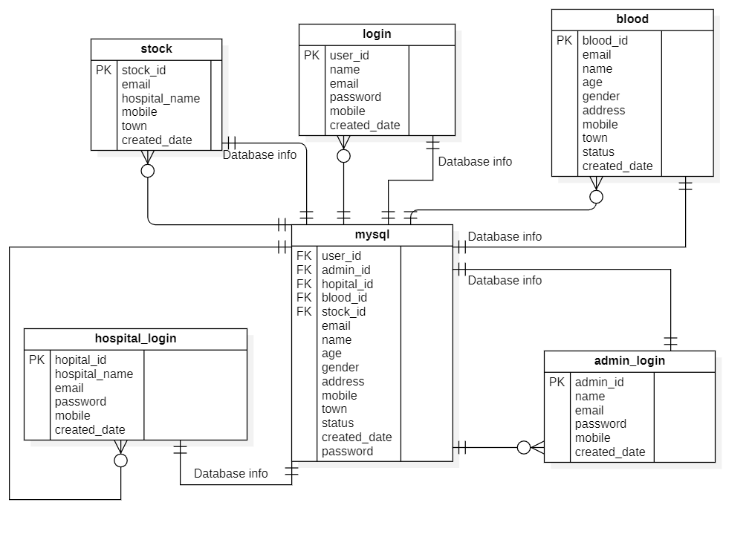
Figure 3.4 Entity Relationship diagram

Chapter 4: Design, Implementation and testing

4.1. Introduction
There is a software development model that is followed for each project. Furthermore, it usually depends on the approach that is taken. Explain how it will impact the procedure by offering benefits and drawbacks.

4.2. The software development model used
This project will use the Waterfall method.

4.3. Justification of the model selected
The Waterfall approach uses a liner starcher throughout development, which facilitates accurate and quick completion of phases.
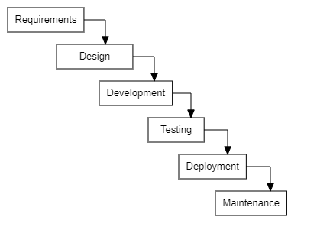
Figure 4.1 Waterfall model

4.4. Advantage of the selected approach
For the website and application of the project, the selected method provides several noteworthy benefits in terms of data administration and analysis. Through effective collection, storage, and analysis of various blood donation-related data, such as donor demographics and stock levels, the project improves its capacity to produce detailed reports and dashboards. This makes it possible to assess the effects of campaigns, monitor performance indicators more effectively, and make well-informed decisions that will ultimately boost output and save more lives through improved blood donation management.

4.5. Alternative model/ approach
The agile approach:
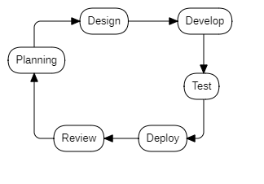
Figure 4.2 Agile model

4.6. Justification for not selecting the alternative approach
Even though the agile model continues to advance. This is an approach that you will never truly be done with. The waterfall model allows you to avoid spending a lot of time and effort on this approach, as it establishes a timeline from the beginning and allows you to track your progress without pausing between phases. The starting and stopping between the pushing and planning phases is one of the main causes of this.

4.7. Database design
To showcase your project, it is appropriate to use the design as a backdrop. Along with its features, the design addresses the data flow and how the program should operate. The database for this project will contain two primary tables. There will be two student and instructor databases, as well as several tables in the database that interfaces with the system, including the Calander and feedback tables.

4.7.1. Mysql table:
Collect every single piece of information on mysql table.
Table 4.1 Mysql table
mysql
user_id | Integer
admin_id | Integer
hospital_id | Integer
blood_id | Integer
stock_id | Integer
email | String
name | String
age | Integer
gender | String
address | String
mobile | Integer
town | String
status | String
created_date | Integer
password | String

4.7.2. Blood table:
This table shows the attributes that will be auto store in the database from users.
blood
blood_id | Integer
email | String
name | String
age | Integer
gender | String
address | String
mobile | Integer
town | String
status | String
created_date | Integer
Table 4.2 Blood table

4.7.3. Login table:
This table shows user login attributes that will be auto store in the database.
Table 4.3 Login table
login
user_id | Integer
name | String
email | String
password | String
mobile | Integer
created_date | Integer

4.7.4. Stock table:
This table shows the attributes that will be auto store in the database from hospitals.
Table 4.4 Stock table
stock
stock_id | Integer
email | String
hospital_name | String
mobile | Integer
town | String
created_date | Integer

4.7.5. Hospital table:
This table shows hospital login attributes that will be auto store in the database.
Table 4.5 Hospital table
hospital_login
hospital_id | Integer
hospital_name | String
email | String
password | String
mobile | Integer
created_date | Integer

4.7.6. Admin table:
This table shows the attributes that will be auto store in the database.
Table 4.7 Admin table
admin_login
admin_id | Integer
name | String
email | String
password | String
mobile | Integer
created_date | Integer

4.8. User interface design:
It is part of the design, it covers the welcome, login and registration page, after logging in to display the user page or the hospital page, by looking at the diagram you can see that the application will be divided into two sides according to the type of user if it is a user or a hospital.

4.8.1. Website:
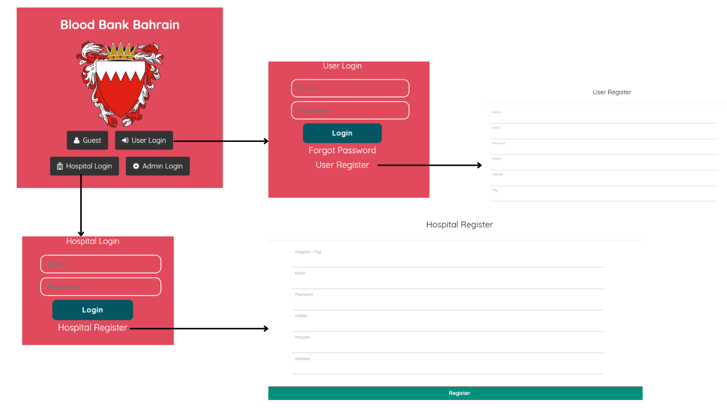
Figure 4.3 Website interface

4.8.2. Application:
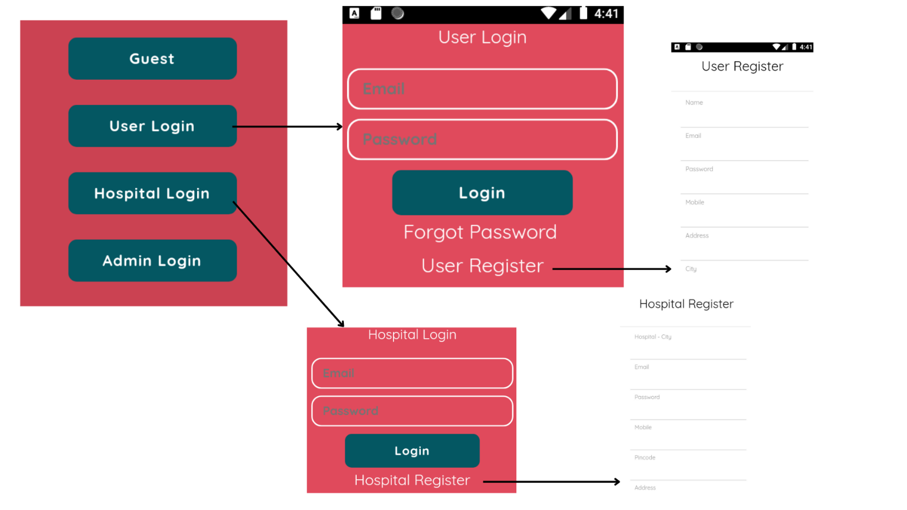
Figure 4.4 Application interface

4.9. Design Diagrams (flow chart diagram)
This diagram will show where the application ends, checks, and sends documents into or out of the database. It is evident that the application will terminate itself if the user chooses not to create an account or if they do not have one.
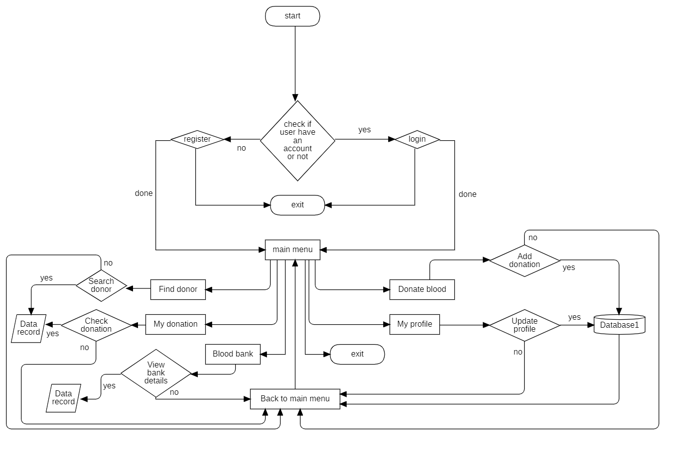
Figure 4.5 Flowchart diagram

4.10. Implementation

4.10.1. Database:
This project will be using XAMPP which is set of open-source web servers, and my database will be MySQL database. XAMPP has a lot of features along lines of:
- Cross-Platform Compatibility: A vast array of developers can utilize XAMPP due to its compatibility with several operating systems, such as Windows, Linux, macOS, and Solaris.
- Apache Web Server: One of the most popular web servers in the world, the Apache HTTP Server, is included with XAMPP. A stable and dependable foundation for hosting and serving web content is offered by Apache.
- MySQL Database: The well-known open-source relational database management system MySQL is included with XAMPP. With MySQL, developers may design, administer, and query databases used for online application data archiving and retrieval.
- Support for PHP, Perl, and Python: Server-side scripting languages like PHP, Perl, and Python are supported by XAMPP. These programming languages are frequently used to create dynamic, interactive websites.
- phpMyAdmin: A web-based graphical interface for MySQL database management, phpMyAdmin is included with XAMPP. Database administration features offered by phpMyAdmin include the ability to create, change, and remove databases, tables, and records.
- Perl and Python Interpreters: included with XAMPP, enabling programmers to execute scripts composed in these languages straight from their local development environment.
- Virtual Hosts: With XAMPP's support for virtual hosts, developers can run several websites or web apps on a single server. Better project organization and isolation during development are made possible by virtual hosts.
- Development Tools: XAMPP comes with several libraries and development tools that are frequently used in web development, including OpenSSL, cURL, the GD Graphics Library, and more. These technologies improve developers' skills and offer more features for creating sophisticated web applications.
All things considered, XAMPP provides a complete and intuitive environment for web development, including all the necessary parts and instruments for building, testing, and launching web applications locally.

4.10.2. Coding software:
Occasionally there is a need to switch from Android Studio to Visual Studio sometimes as the chosen coding program of choice for this project to increase implementation efficiency.
This shift was partially caused by Android Studio's increased requirements for my computer, which I am unable to upgrade at this time. Additionally, Visual Studio performs exceptionally well when working with the HTML and CSS languages that this software uses. Additionally, Visual Studio offers the ability to inspect modifications made to the application without having to restart the program, which saves a significant amount of time during the implementation phase. Also supported by Visual Studio are Android devices.
All the aforementioned information indicates that Visual Studio's coding software may easily meet the application's coding software requirements and, in certain cases, even exceed them.

4.10.3. Coding Language (HTML & CSS & PHP):
The core web development technologies are HTML (Hypertext Markup Language), CSS (Cascading Style Sheets), and PHP (Hypertext Preprocessor). Each is essential to the creation of dynamic and eye-catching websites.
HTML: Web pages are built on HTML, which also provides the content's structure and layout. Developers can define different elements, such headings, paragraphs, photos, and links, and arrange them logically in a hierarchy for readability and ease of navigation.
CSS: By managing how web material is presented and styled, CSS enhances HTML. Developers can alter HTML elements' appearance, including things like color, typeface, spacing, and layout, via CSS. Because content and presentation are kept separate, developers may produce aesthetically beautiful websites with clear, manageable code.

PHP: PHP is a scripting language that runs on servers and is used to create dynamic websites. It enables developers to manage form submissions, create dynamic content, communicate with databases, and carry out a variety of server-side operations. Developers can utilize PHP to construct dynamic, robust websites that are customized to each user's unique requirements.

XAMPP: With the help of the well-known software package XAMPP, developers may create and test websites in a fully functional environment that comprises Apache, MySQL, PHP, and Perl. A powerful relational database management system called MySQL is part of XAMPP and gives developers effective means of storing, retrieving, and manipulating data. HTML, CSS, PHP, and XAMPP are used to develop feature-rich online applications with dynamic content and interactive capabilities. HTML and CSS oversee how web pages are presented and laid out, whereas PHP handles server-side processing and database interfaces. XAMPP can be used to test and implement the apps locally before deploying them to a live server.

4.10.4. <Blood Bank Bahrain> implementation:
Since the software needs a search engine, it is imperative to use effective filtering methods to guarantee quick results retrieval. Hashing algorithms are renowned for their speed and effectiveness, especially in real-time search circumstances, according to studies. But there are other methods to consider when using XAMPP, which is a complete software package that includes Apache, MySQL, PHP, and Perl. One essential part of XAMPP is MySQL, which has powerful features for organizing, querying, and storing data. Although hashing techniques are praised for their speed, MySQL in XAMPP has benefits of its own. With support for several indexing strategies, scalability, and query optimization, MySQL can manage program searches well. Additionally, XAMPP offers the convenience of hosting the program's database locally, which makes development, testing, and deployment easier in a safe setting. This local configuration protects privacy and security of data while streamlining the development process.
Searching |  | Time Complexity
algorithms | Best | Average | Worst
Linear search | O(1) | O(n) | O(n)
Binary search array | O(1) | O(log n)
Binary search tree | O(1) | O(log n) | O(n)
Hashing | O(1) | O(1) | O(n)
Breadth/depth-first of graph | O(1) | O(V+E)  No vertices + No edges | $${O(V}^{2})$$
Table 4.6 Algorithm table

4.10.5. Database implementation:
This database list gathers all user emails and includes comprehensive data including names, phone numbers, email addresses, passwords, and user IDs.
Features:
Add: Without logging in, you can add a new user and add all of their information.
Browse: If you want to make sure the details are accurate, you can look through all of them.
Search: This database's search function is its greatest feature. For instance, looking up someone's ID is simple and accessible.
Insert: If you'd like, you can also add more information to the database.
Empty: If you'd like, you can click once to remove all the current information.
Drop: If you'd like, you can remove the database in its entirety.
Table 4.7 Database table
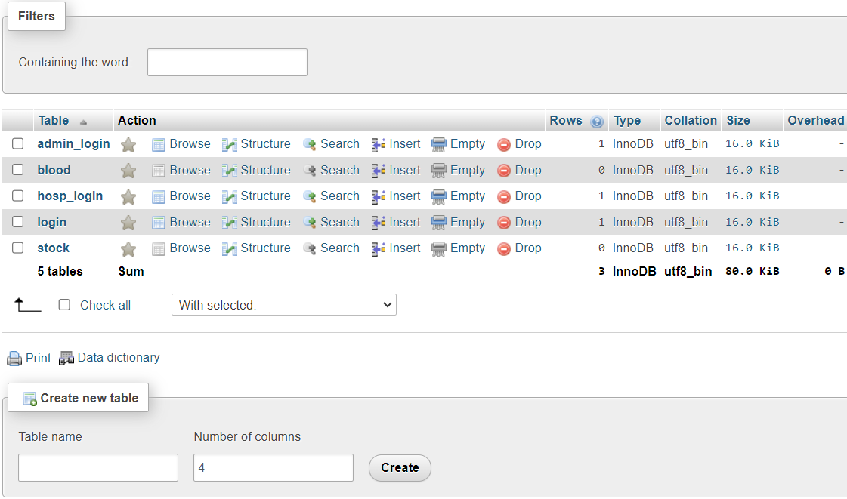
Add table:
Figure 5.8 Database table (Add table)
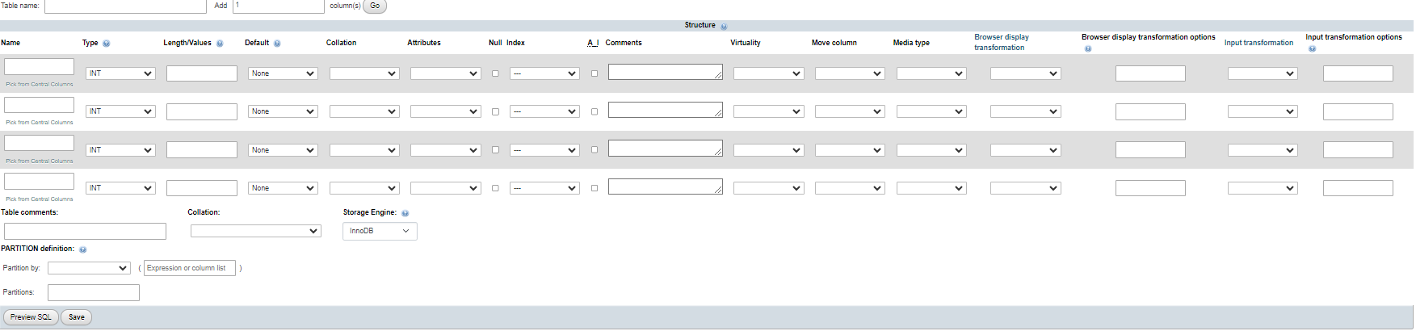
Browse table:
Table 4.9 Database table (Browse table)
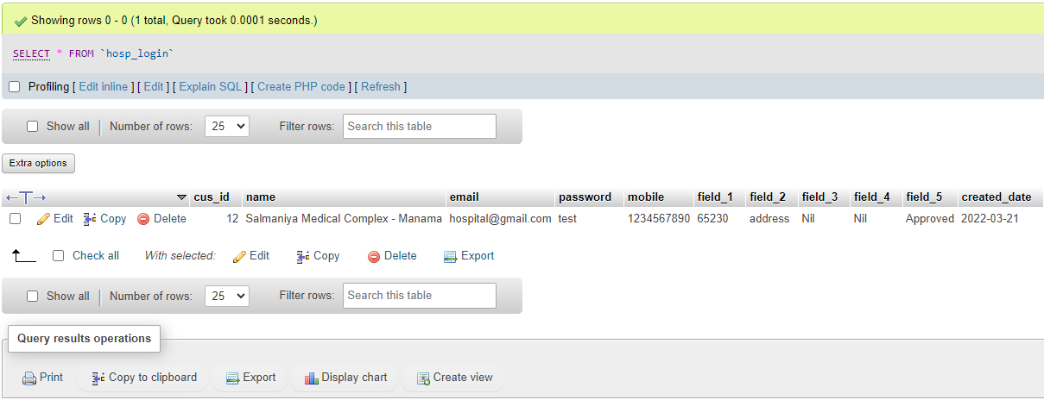
Search table:
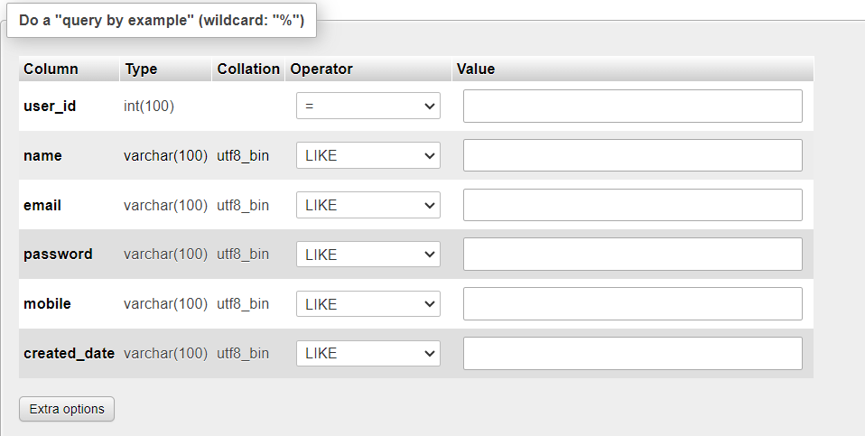
Table 4.10 Database table (Search table)

Insert table:
Table 4.11 Database table (Insert table)
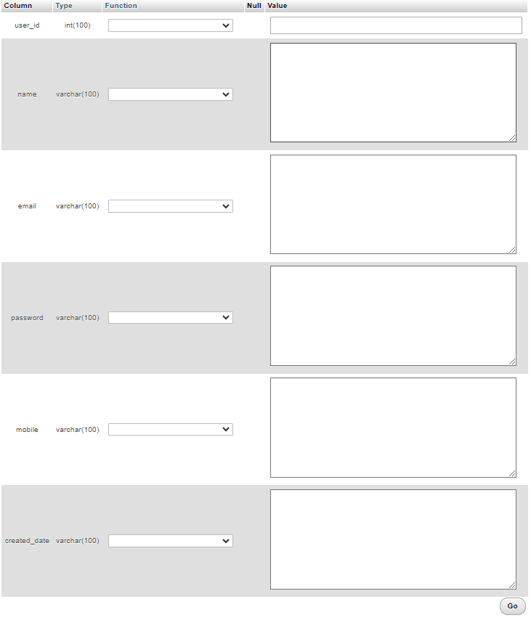
Empty table:
Table 4.12 Database table (Empty table)
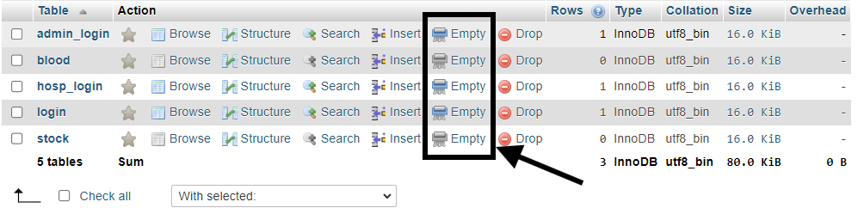
Table 4.13 Database table (Drop table)
Drop table:
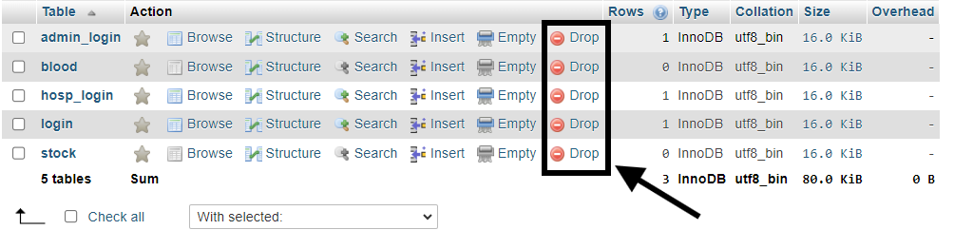

4.10.6 Software implementation
First when the user runs the software, a main page will appear, this page will give the user a choice if the user is a guest or normal user or hospital or admin.
Login (Guest): Choosing a guest will not appear any login or register page, it will connect you to the main page immediately, and you will allow limited access to the web & app, and you can’t add donor or request blood as a guest.

Website:
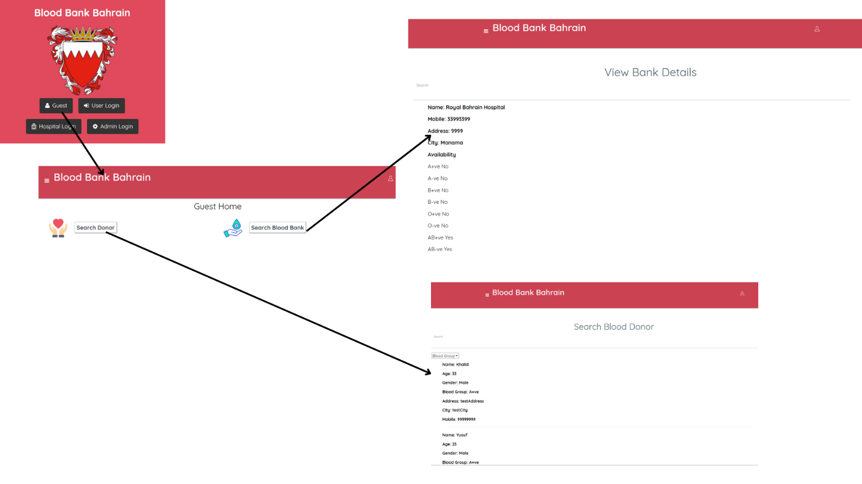
Figure 4.6 Guest Main Page Website
Application:
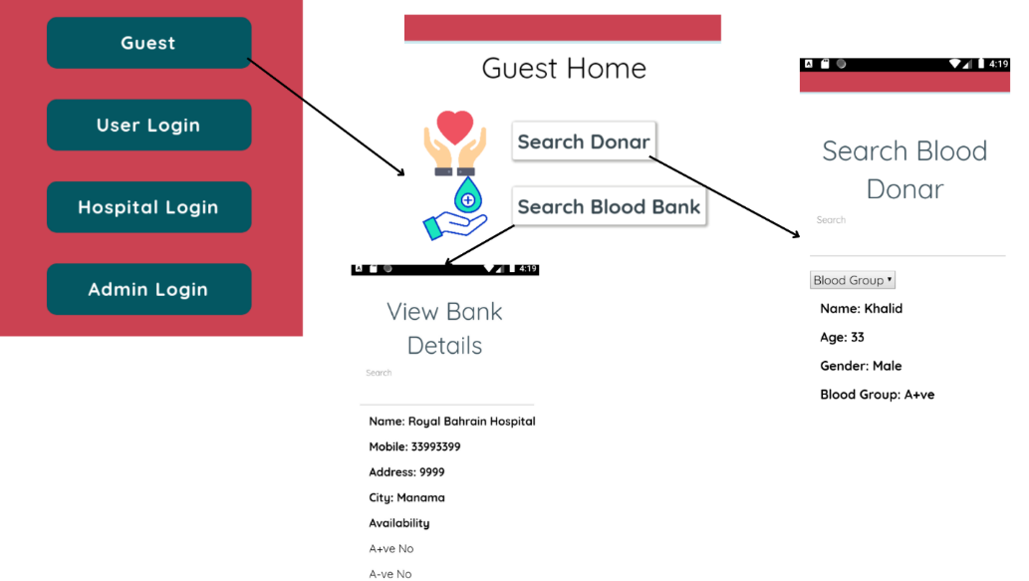
Figure 4.7 Guest Main Page Application
The user can donate blood, can request blood, and can view donors and the blood bank.
Login (User): If you choose the user button, then you must login or register if you don’t have an account.
Website:
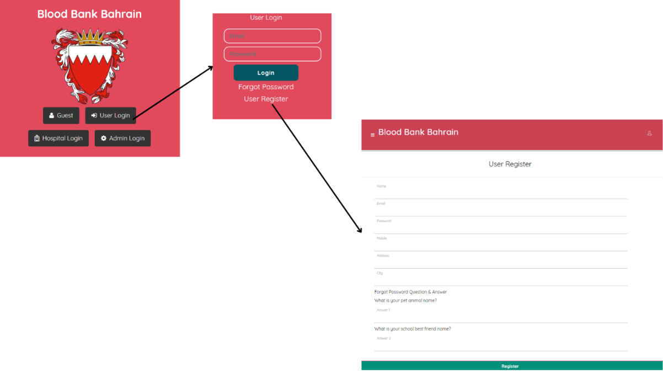
Figure 4.8 User Login Page Website
Application:
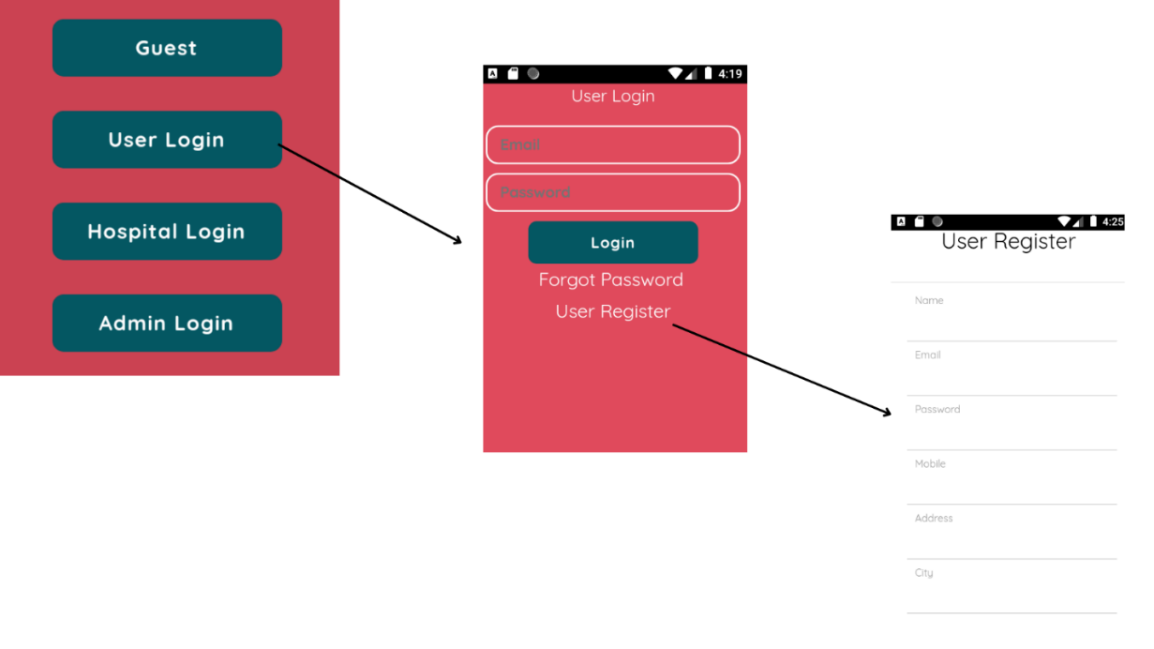
Figure 4.9 User Login Page Application
After logging in or registering, you will go to the main page so you can choose any of the buttons below:

Website:
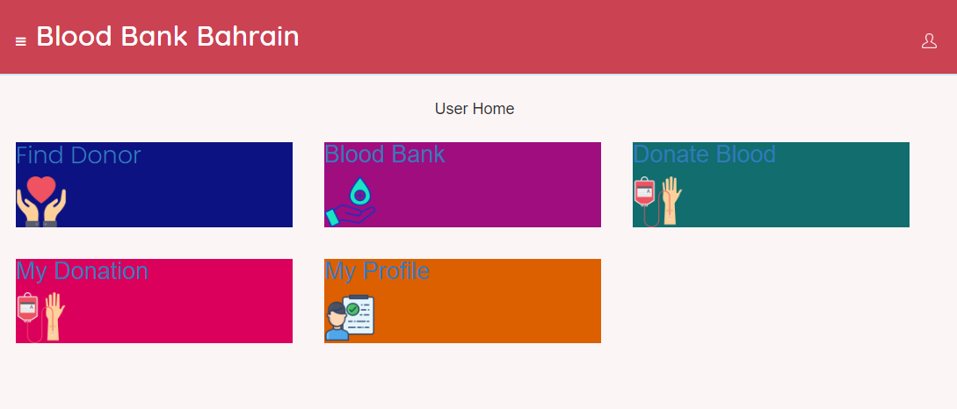
Figure 4.10 User Main Page Website
Application:
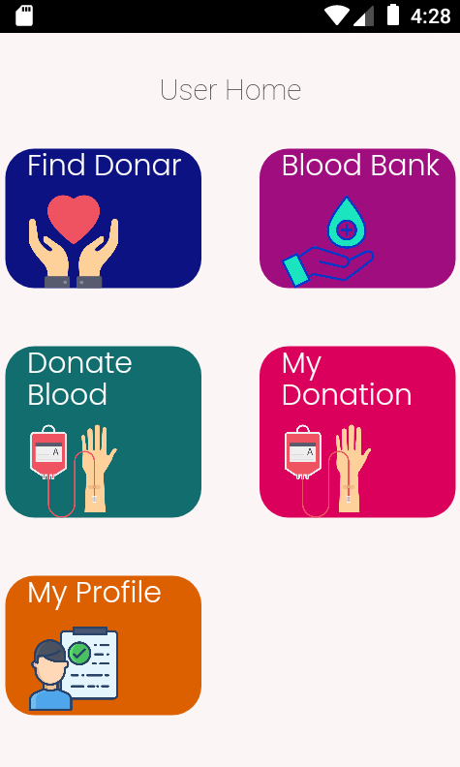
Figure 4.11 User Main Page Application
Button 1: Find Donor
You can find a donor as a user.
Website:
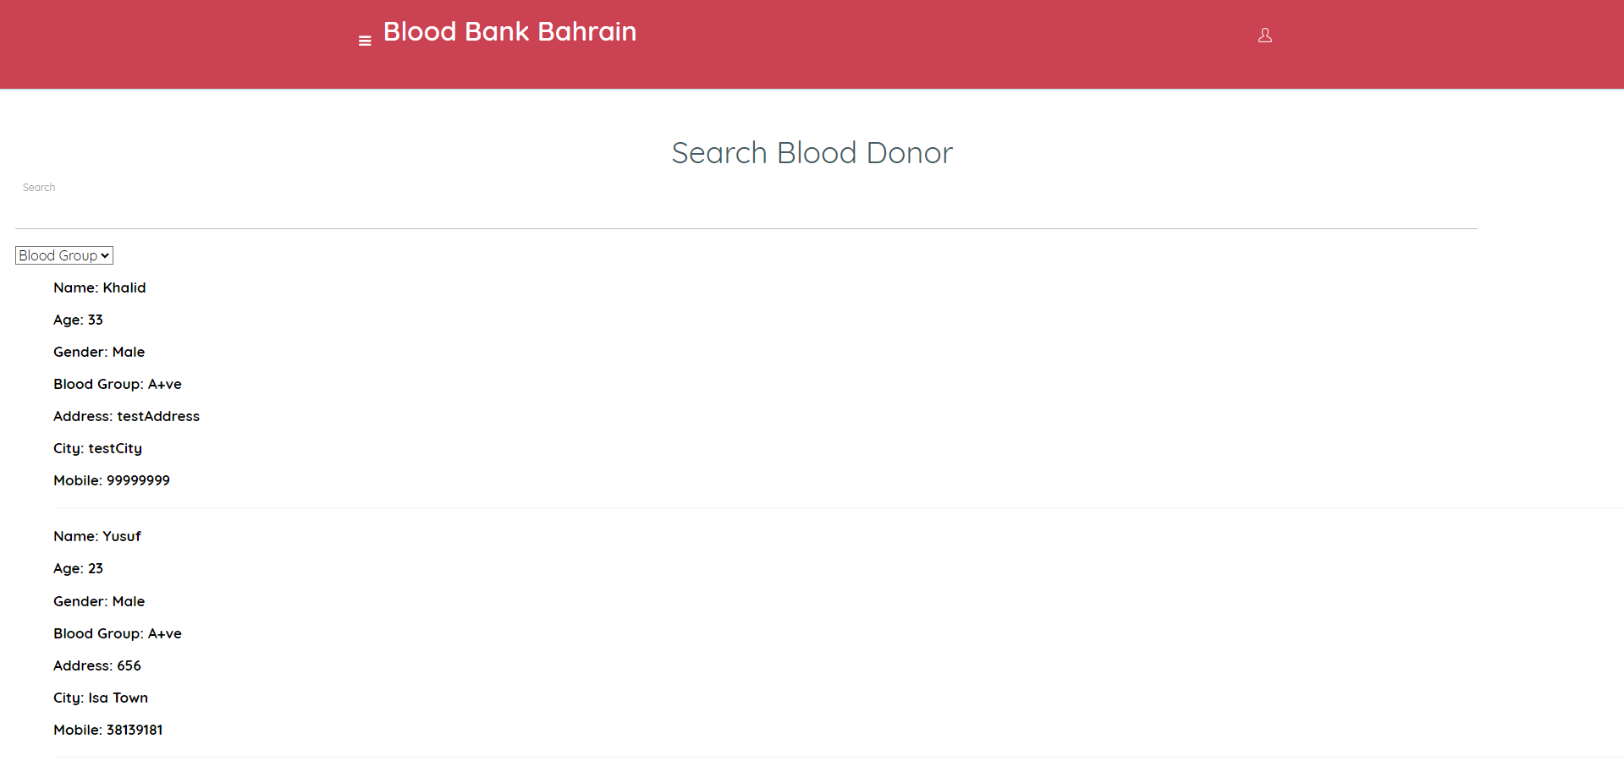
Figure 4.12 User Donor Page Website
Application:
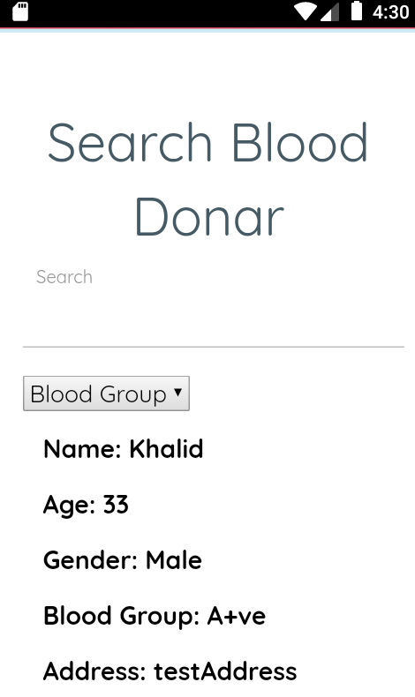
Figure 4.13 User Donor Page Application

Button 2: Blood Bank
You can view blood banks from hospitals as a user.
Website:
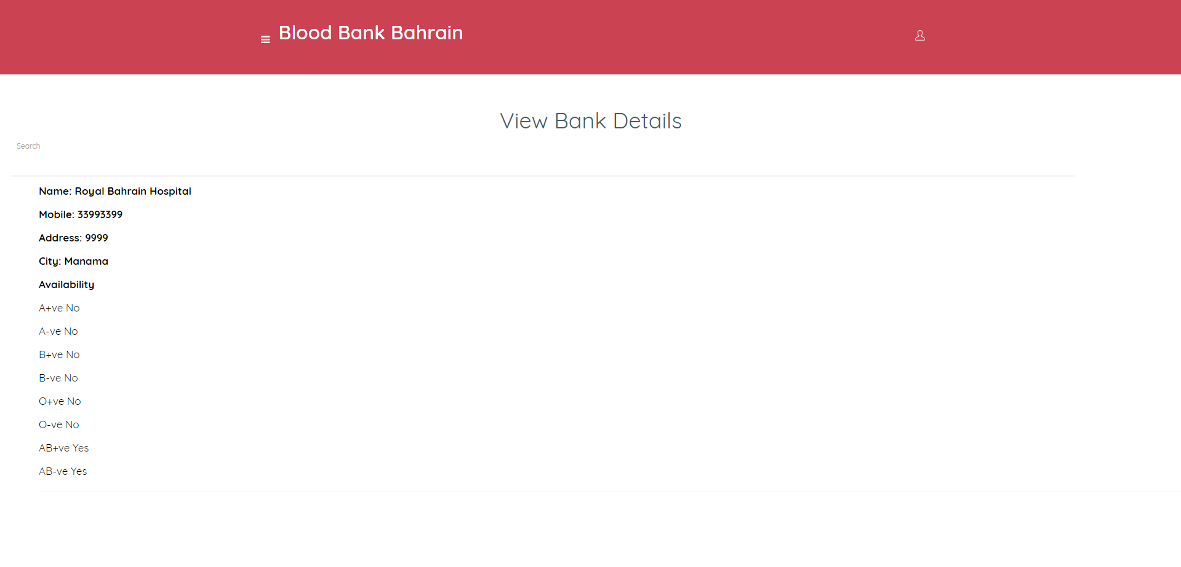
Figure 4.14 User Blood Bank Details Website
Application:
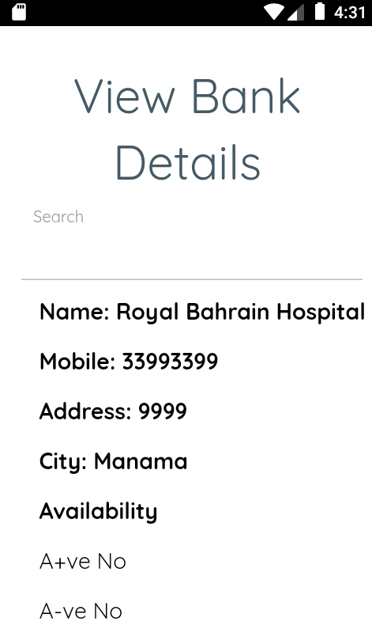
Figure 4.15 User Blood Bank Details Application

Button 3: Add Donor
You can add a new donor to the web & app as a user.
Website:
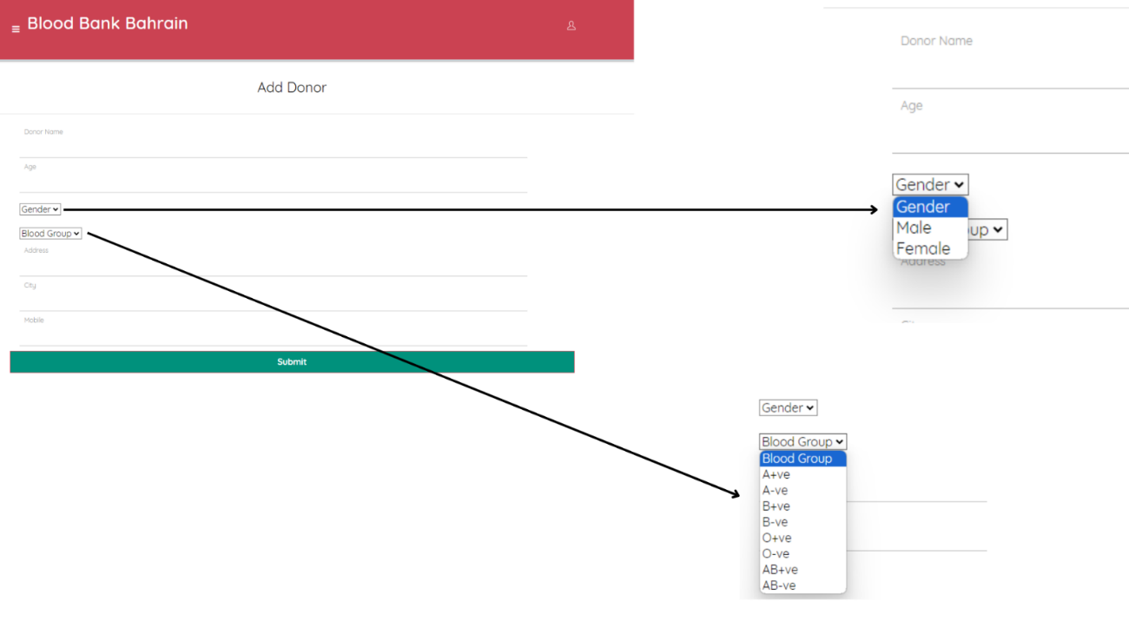
Figure 4.16 User Add Donor Website

Application:
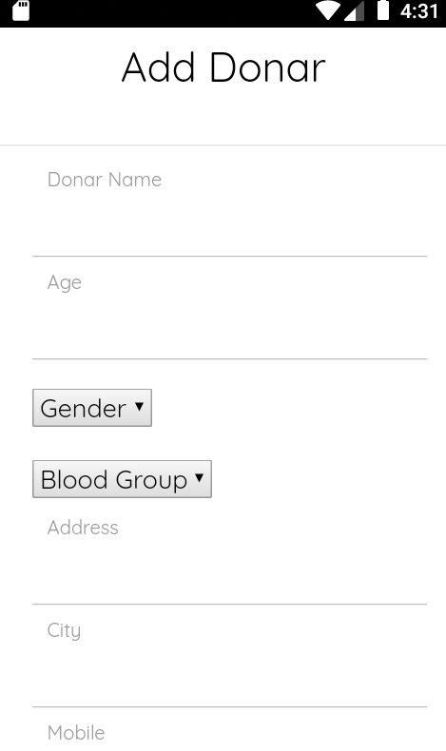
Figure 4.17 User Add Donor Application

Button 4: My Donation
You can view your donation as a user.
Website:
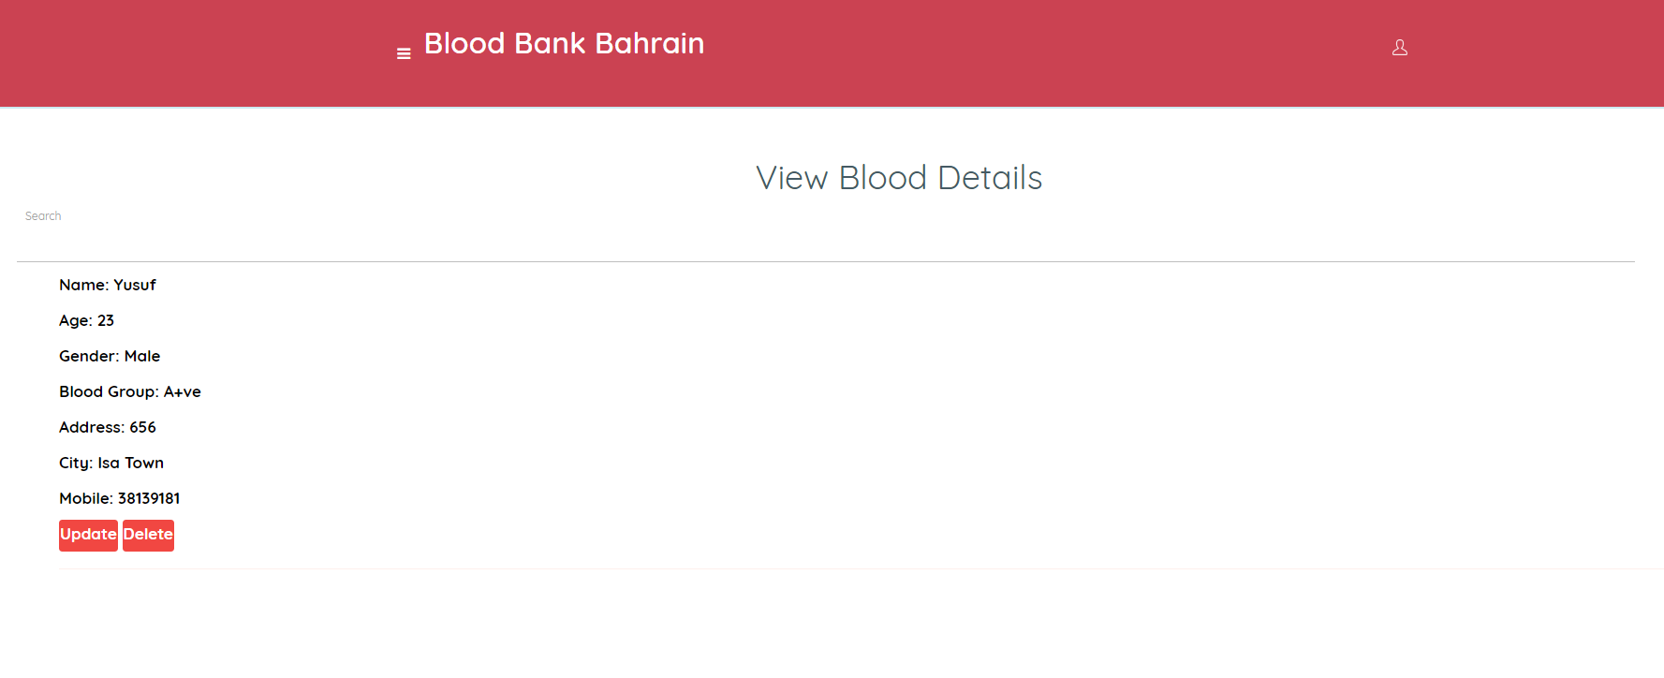
Figure 4.18 User Edit Details Website

Application:
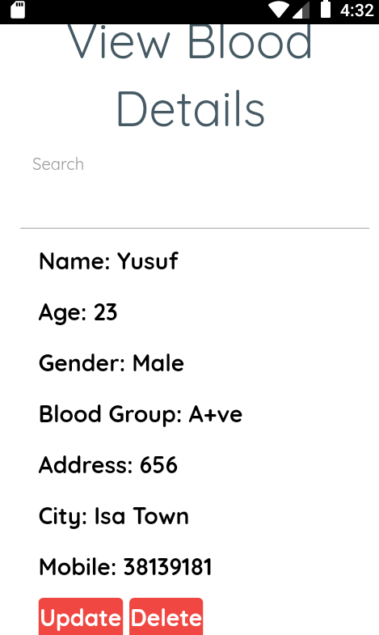
Figure 4.19 User Edit Details Application

Button 5: My Profile
You can edit your profile as a user.
Website:
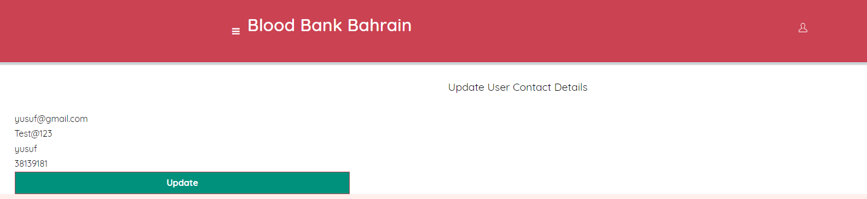
Figure 4.20 User Edit Profile Website
Application:
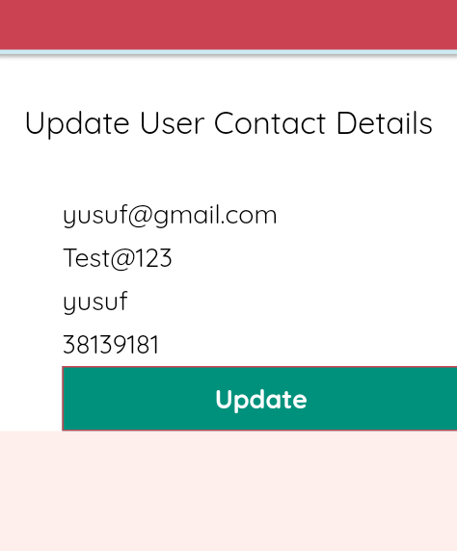
Figure 4.21 User Edit Profile Application

The hospital user can donate blood or request blood and can edit blood bank details.
Login (Hospital): If you choose the hospital button, then you must login or register if you don’t have an account.
Website:
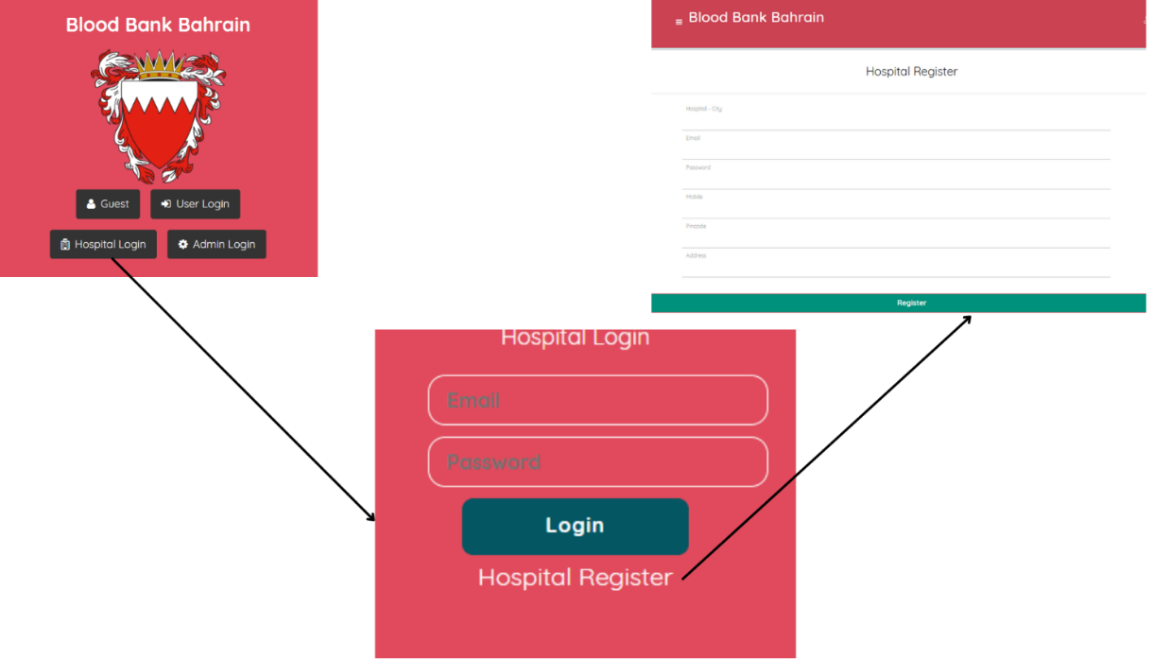
Figure 4.22 Hospital Login Page Website
Application:
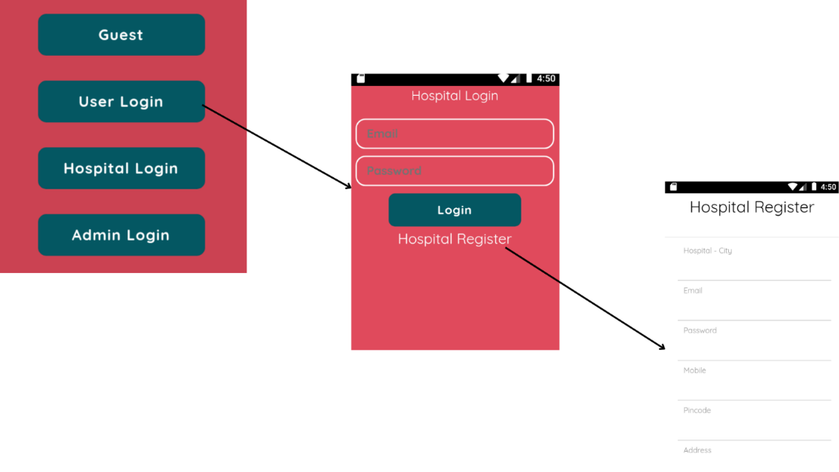
Figure 4.23 Hospital Login Page Application

After login or register, you will go to the main page, you can choose any of the buttons below:
Website:
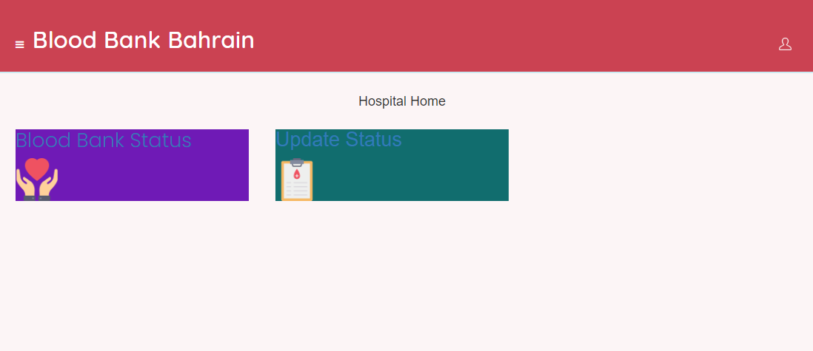
Figure 4.24 Hospital Main Page Website
Application:
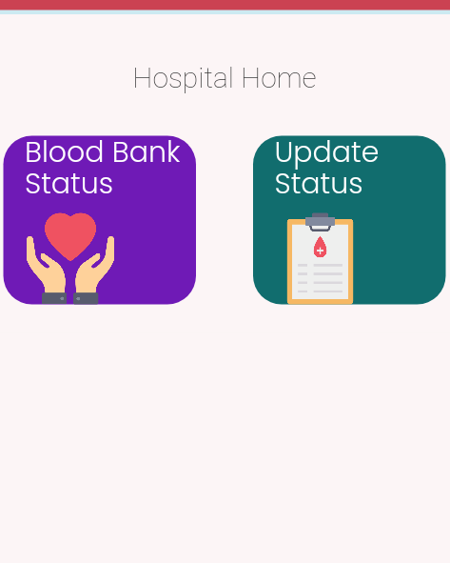
Figure 4.25 Hospital Main Page Application

Button 1: Blood Bank Status
For the hospitals who want to add a new blood bank.
Website:
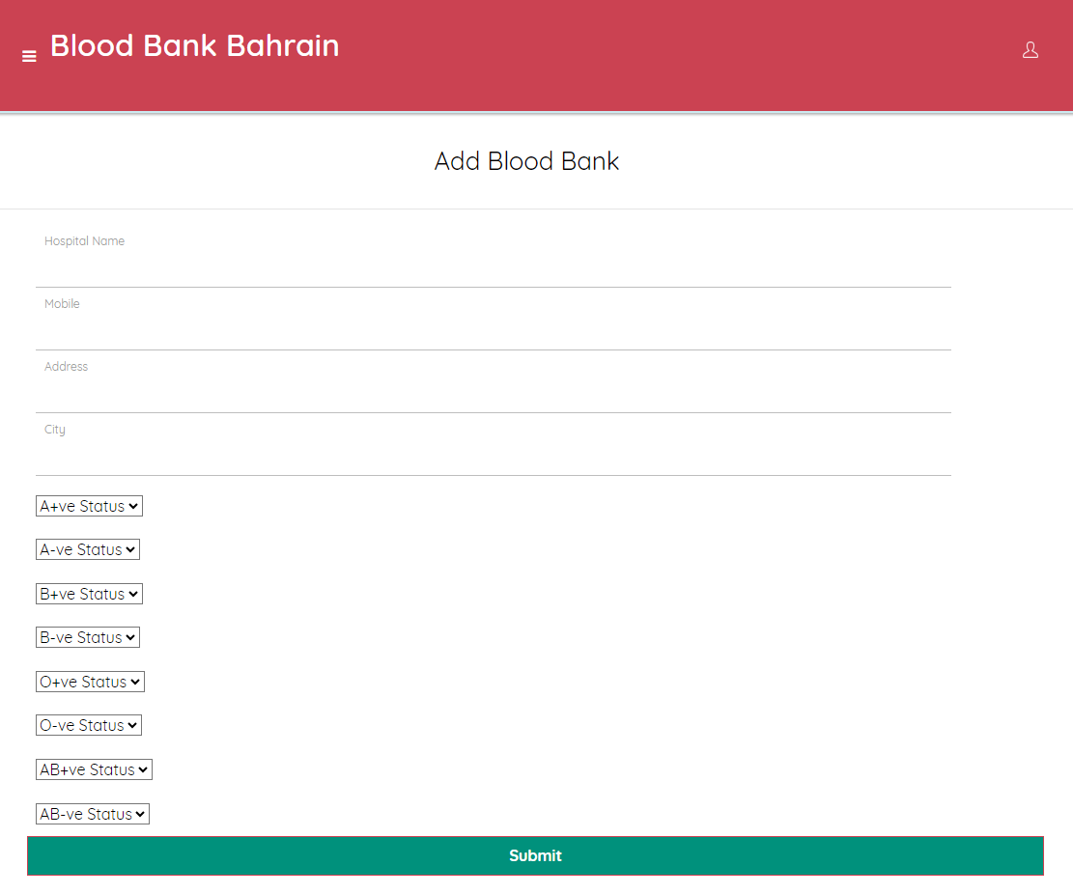
Figure 4.26 Hospital Add Blood Bank Website
Application:
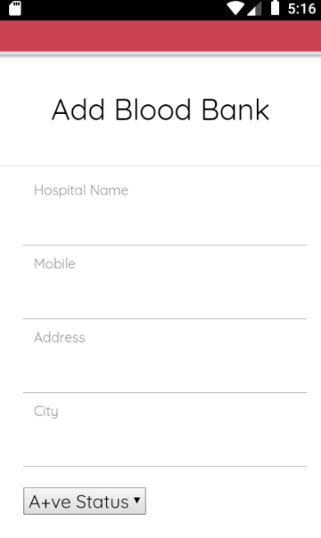
Figure 4.27 Hospital Add Blood Bank Application
Button 2: Update Status
The hospitals can update blood bank information, and they can delete it.
Website:
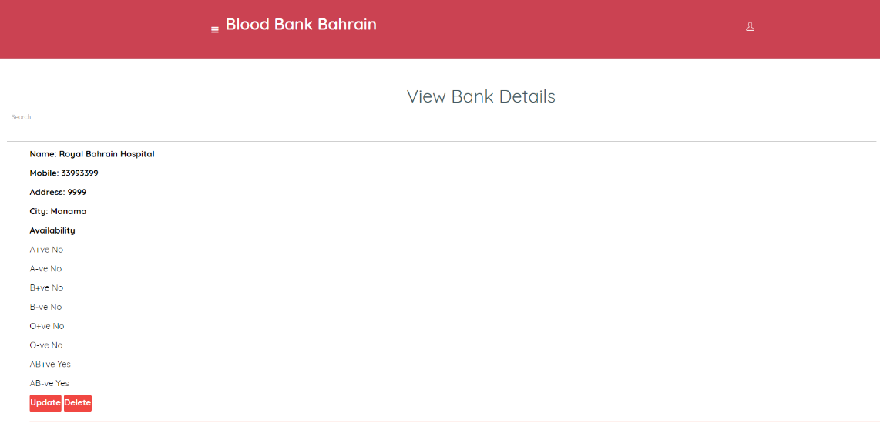
Figure 4.28 Hospital Edit Details Website
Application:
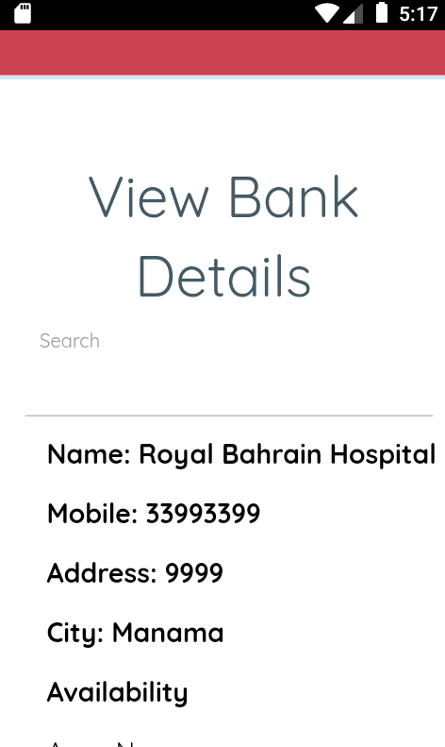
Figure 4.29 Hospital Edit Details Application
The admin can print the bank reports by Excel, and she/he can access some data like:
ID & Name & Age & Gender & Blood type & Address & City, Mobile & Email.
Also, the admin can’t register like normal users.
Here’s how the main page will be:
Website:
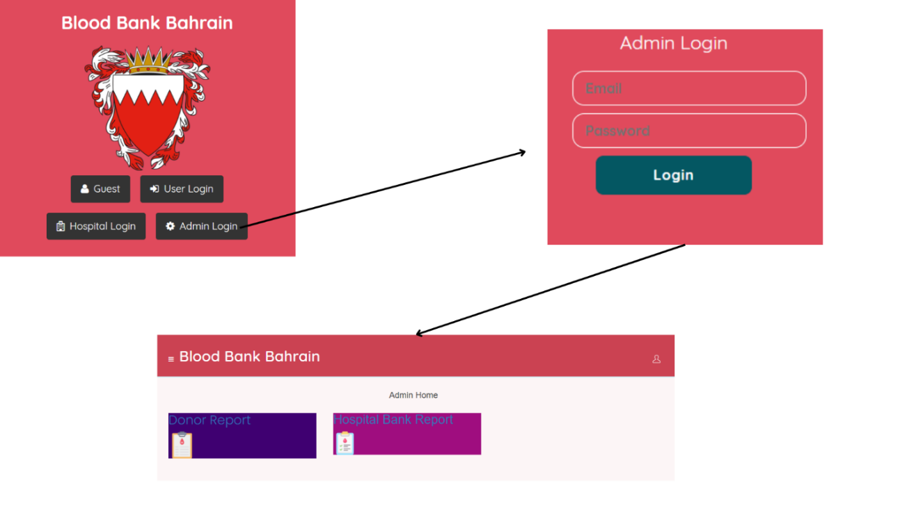
Figure 4.30 Admin Main Page Website
Application:
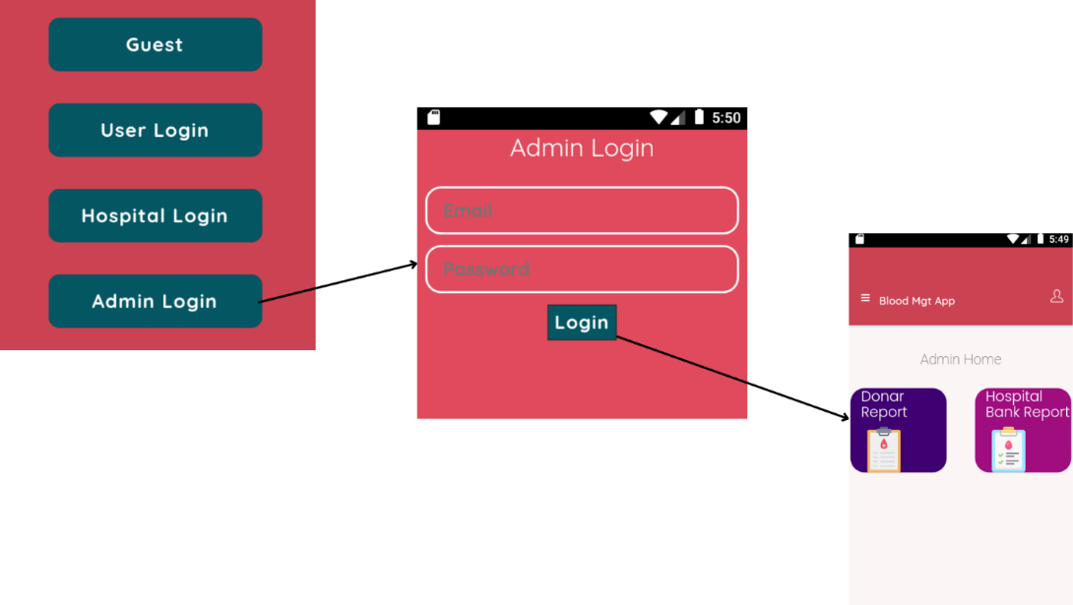
Figure 4.31 Admin Main Page Application
Button 1: Donor Report
Here’s the user’s report.
Website:
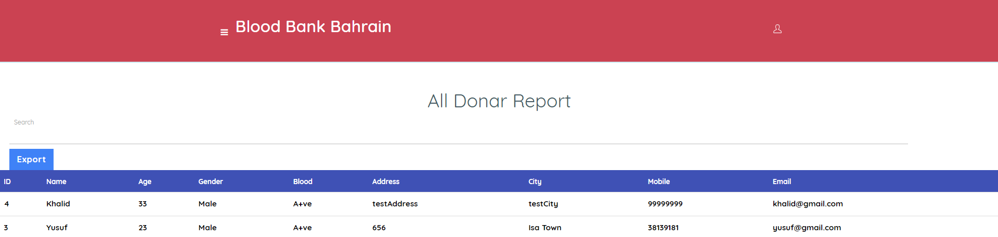
Figure 4.32 Admin Donor's Report Website
Application:
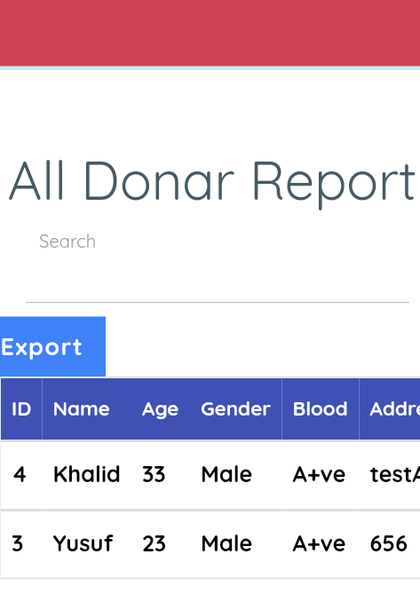
Figure 4.33 Admin Donor's Report Application
Button 2: Hospital Bank Report
Here’s the hospital’s report.
Website:
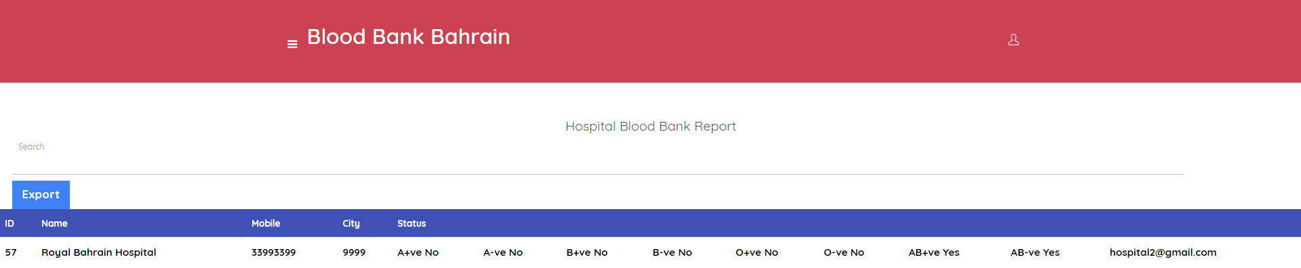
Figure 4.44 Admin Hospitals Report Website
Application:
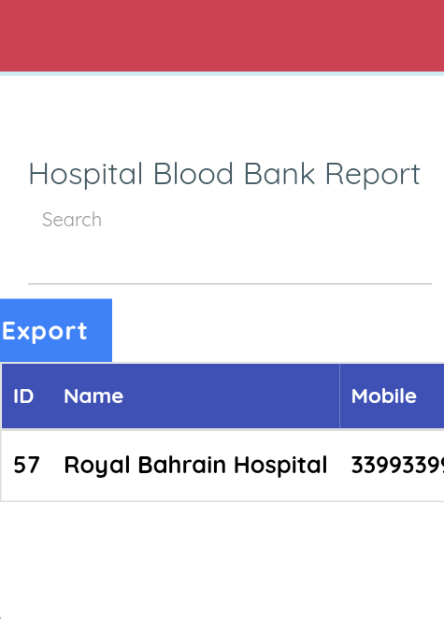
Figure 4.45 Admin Hospitals Report Application

4.11. Testing
Due to its complexity, the database had several problems during testing. For example, XML was used for the Android application and Angular.js was used for the online application. Setting up a link between Angular.js, PHP, and XML was necessary for this. While the web application and database operated together without any issues, the XML integration was the unique source of the issue.
To further inform users about blood donation, a video that was previously limited to the website was removed from the Android application.

4.11.1. Testing (solve android database):
Cordova was used to connect to the database, which proved to be simpler than expected and fixed Android issues. However, Cordova had to be studied for a minimum of three days prior to the link being implemented. The procedure of using Cordova with the Android application is shown in the screenshot below [9].
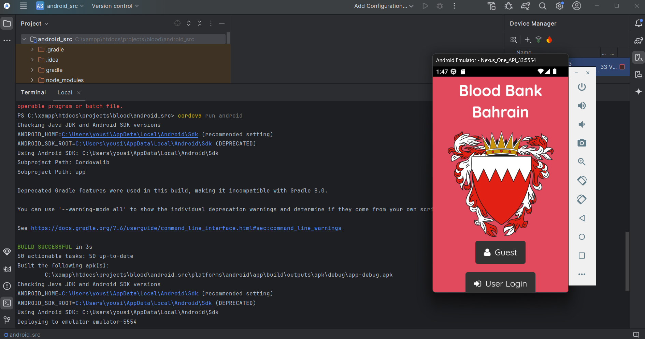
Figure 4.46 Cordova testing

4.11.2. Testing (adding ABO video & Ads to my website):
The four primary blood types (A, B, AB, O) and their functions within the ABO system are explained in a movie that was added, as seen in the image below. Giving a thorough explanation of each blood type and its significance is the aim of this video, and you can explore essential health resources, including Bahrain's latest research initiatives, emergency hotlines, and efforts towards sustainable development with ABO video.
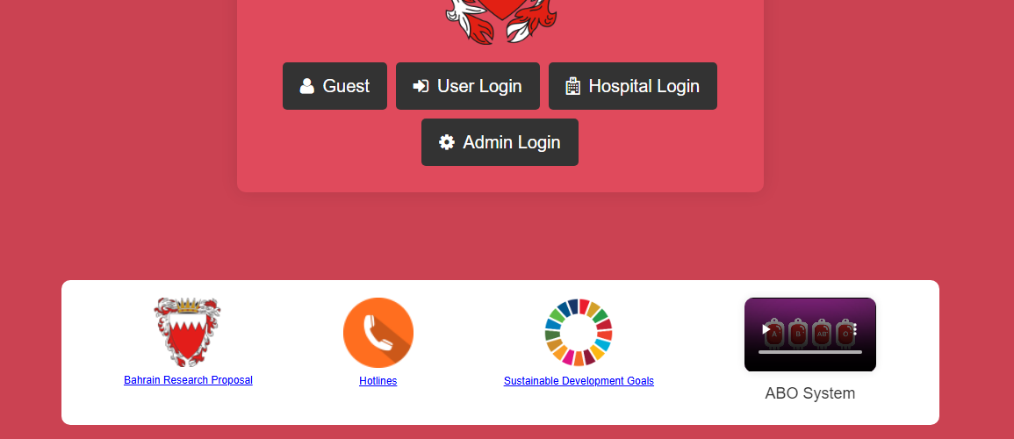
Figure 4.47 ABO System

Chapter 5: Results and discussion

5.1. Findings
Both the application and the website took longer to construct than I had originally thought. This experience made it clear how important teamwork is because it might be daunting to handle everything by yourself, especially when there are tight deadlines. Working together would not only divide the workload but also increase productivity and project quality overall. The importance of choosing the right programming language for project development is yet another important lesson. Working with many languages, including integrating PHP, XML, and Angular.js, made the database connection extremely complicated and difficult to create and explain. Selecting a cohesive and compatible mix of languages could minimize potential technical issues and speed up the development process.

5.2. Goals achieved and unachieved goals

5.2.1. Goals achieved:
- User-Friendly Design: Made sure the website and application are simple for users to use and navigate.
- Functionality: Confirmed that all the website and application buttons and features work as intended.
- Simple Account Creation: Simplified the process of creating an account by letting users enter their details while enforcing validation guidelines, like only permitting eight-digit Bahraini numbers.
- Admin Integration: Added an admin panel to the project that allows users to see all reports and export them to Excel or print them out for additional examination.

5.2.2. Unachieved goals
- Collaboration with Bahrain's Ministry of Health and Hospitals:
Because of pre-existing problems between these organizations, establishing collaboration with Bahrain's Ministry of Health and hospitals proved to be difficult. It would be essential to settle their internal issues so that they could eventually receive the project donation.
- Forgot Password Button:
The present database programming technique has restrictions that prevented the successful implementation of the "Forgot Password" feature.
- Adding Locations for Every Hospital:
While adding locations for each hospital is feasible, doing so would entail acquiring a Google Maps token, which is currently prohibitively expensive.
Finally, three surgeries, including one very dangerous one, were performed over this course. Notwithstanding these difficulties, every attempt was made to finish the project as high as feasible.

5.3. Future goals

5.2.1. A list of future work:

- Adding IOS compatibility
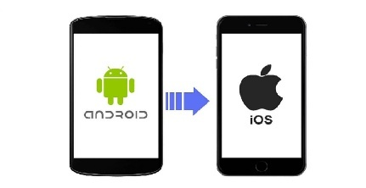
Figure 5.1 IOS Compatibility (Future goal)
- Adding Arabic language.
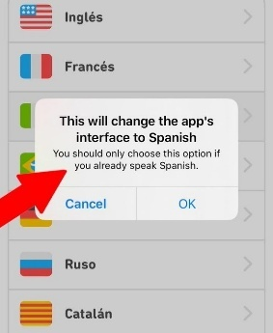
Figure 5.2 Adding Languages (Future goal)
- Adding Notification.
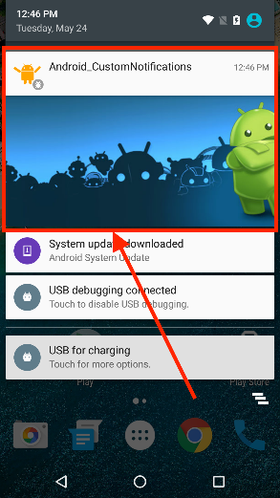
Figure 5.3 Notification (Future goal)

Chapter 6: Conclusions
The Blood Bank Bahrain (BBB) initiative is more than simply a capstone project; it is evidence of my development as a person, my technical proficiency, and my unrelenting will to address one of the most pressing issues facing the healthcare industry. By expediting blood donation procedures, guaranteeing effective blood distribution, and establishing a smooth connection between donors and patients in need, this platform was developed with the goal of saving lives. What makes this project unique, though, is not only its goal but also the tremendous amount of work, perseverance, and commitment required to make it a reality for a single student working on a project of this magnitude.

6.1. Project Part A: Learning Skills
The journey began with immense challenges as I embarked on Part A of the project. As someone with limited prior experience in web and mobile development, I had to build a strong foundation in various programming languages and frameworks to create BBB. I turned to Udemy as a valuable resource, dedicating countless hours to learning essential skills such as:
6.1.1. HTML and CSS: I gained knowledge of HTML and CSS, which helped me organize and create web pages so that the BBB platform would have a user-friendly and aesthetically pleasing interface.
6.1.2. Angular and JavaScript.js: I was able to make the website responsive and user-friendly by incorporating dynamic and interactive elements.
6.1.3. Bootstrap: I became proficient with Bootstrap to improve the platform's responsiveness and design, allowing me to produce a standardized and polished layout.
6.1.4. PHP and SQL: PHP and SQL served as the project's foundation, enabling me to manage databases, conduct server-side processing, and guarantee smooth data integration.
6.1.5. Cordova: This was especially important because it allowed me to create the Android app for BBB and make sure it integrated with the website.
The fact that Blood Bank Bahrain has both an Android app and a website added to the project's complexity. Managing and designing a shared database that served both platforms at the same time was extremely difficult for a single developer. To guarantee that data was synchronized and available on the website and mobile app, careful planning, debugging, and problem-solving were necessary. One of the most challenging technical elements of the project was dual-platform integration, but it was also one of the most fruitful since it gave BBB the opportunity to reach a larger audience and increase its influence.

6.2. Project Part B: Overcoming Personal Challenges
The project's technological aspects weren't the only difficulties. Personal struggles characterized Part B of the voyage, as I had to have three operations, one of which was very critical, and dealt with substantial health difficulties. My physical and mental limits were put to the test during these surgeries, but I never wavered in my resolve to finish Blood Bank Bahrain. I am incredibly appreciative of Allah for giving me the fortitude and tenacity to carry on with the undertaking despite these difficulties. This accomplishment would not have been feasible without His direction. I am also incredibly grateful to my family, particularly my father, whose constant encouragement and support helped me stay focused throughout my trying moments. My doctors made sure I could heal and keep working toward my goals, and my friends were invaluable in helping me stay focused and provide emotional support. I was able to get past these challenges and complete the job thanks to their combined assistance.

6.2. Collaborating with the Ministry of Health
Working with the Ministry of Health Gaining the cooperation of Bahrain's Ministry of Health to guarantee that Blood Bank Bahrain complied with the nation's healthcare regulations and facilities was another major obstacle. This required presenting the project to officials, navigating intricate administrative procedures, and securing the required permissions. Although coordinating and communicating with such a significant organization was extremely difficult for me as a student, it was an essential step in making BBB a reality. I learned the value of perseverance, professionalism, and clear communication from this experience.

6.3. The Legacy of Blood Bank Bahrain
Despite the many obstacles, I am pleased to have finished Blood Bank Bahrain, a platform that combines humanitarian efforts with technological innovation. It tackles important problems in blood distribution and donation, offering a dependable and effective method to save lives, shorten emergency response times, and increase public awareness of the value of blood donation. BBB connects donors and patients by utilizing cutting-edge technologies and a common database for the website and Android app, resulting in a smooth and powerful user experience. Additionally, the project seeks to encourage people to make significant contributions to society by fostering a culture of accountability and generosity within the community.

6.4. A Journey of Growth and Gratitude
This trip has been a life-changing experience that has taught me the virtues of fortitude, tenacity, and thankfulness in addition to technical skills. I will always be proud of the accomplishment of finishing Blood Bank Bahrain as a single developer while juggling the demands of health, schooling, and working with outside organizations. I give thanks to Allah, my loved ones, friends, doctors, and all those who helped me along the journey. Blood Bank Bahrain is a movement that represents optimism, solidarity, and advancement rather than merely a project. It serves as a reminder of what can be accomplished with perseverance, creativity, and the teamwork of a community committed to saving lives. To guarantee that no life is lost because of the unavailability of this life-saving resource, I hope that BBB will keep expanding and act as a model for future solutions. In addition to marking the end of my academic career, this endeavor marks the start of a lifetime dedication to using technology to advance humankind.
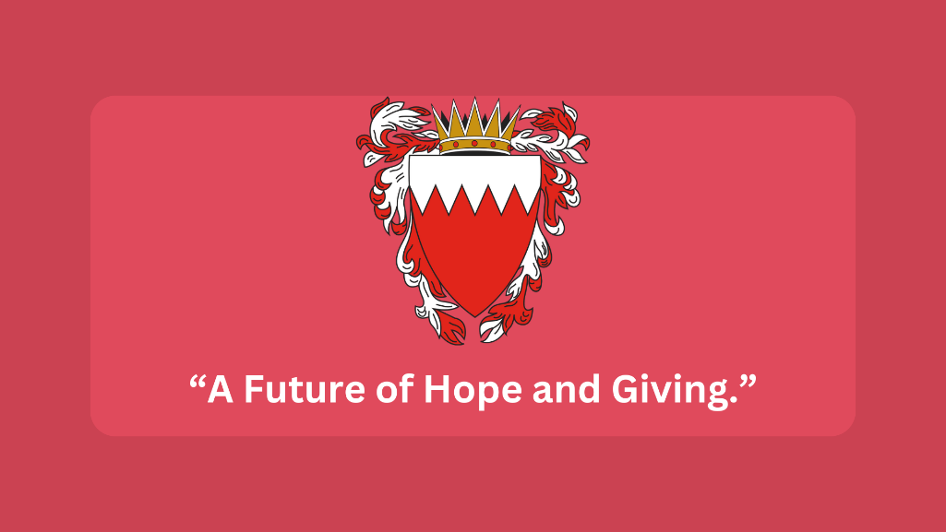
Figure 6.1 A Future of Hope and Giving.

References
1. Internet usage rate in Bahrain. (2024, 3 29). Internet usage rate in Bahrain. Retrieved from Telecommunications of Bahrain: https://bahrain.bh/wps/portal/ar/BNP/HomeNationalPortal/ContentDetailsPage/!ut/p/z0/fY65DoJAFEV_ZRo6kxlciJYuiUtCohYGpiGP4QVGYB7Lw-jfi5YWlie55-ZILSOpHTxsDmzJQTVyrIPEPy7UYblV6rybT9XltroGm9BX4X4mT1L_H4wP9t62ei21Icf4ZBmlrkmg8xSkNLDgAkVpXZ5R7SlGUziqKH9NBGOFhup
2. People who use mobile & web in Bahrain. (2024, 3 29). People who use mobile & web in Bahrain. Retrieved from Telecommunications: https://www.bahrain.bh/wps/portal/ar/!ut/p/z0/nZI7U8MwEIT_yjXpyEgk5EFJSBEoCB2Jmowsn-0jekWSPfjfY5uK8RAGSt3srb5diQl2YMLKhkqZyFmpu_NRLE-3Twu-Wz9yvnt53fLlfrdezVab-d12xp6Z-FnA57x3oPfLRTwwoZxN-JHYIbP-hHbCW1cH0FQgkIVMVkFSNy1dg8EatAmkzSE6RVJDrL13IU14QC0T5pCcJxW_y
3. Bloods types in Bahrain. (2024, 3 30). Ministry of Health. Retrieved from https://www.moh.gov.bh/News/Details/3607
4. Blood donation rate in. (2024, 3 29). Retrieved from Ministry of Health: https://www.moh.gov.bh/News/Details/3607
5. Blood Donation - Ministry of Health. (2024, 4 4). Ministry of Health. Retrieved from Blood Donation: https://www.moh.gov.bh/healthinstitution/blooddonation?lang=en
6. Bahrain Red Crescent Society. (2024, 4 4). Retrieved from Bahrain Red Crescent Society: https://www.rcsbahrain.org/en/donate/
7. Bahrain Open Data Portal. (2024, 4 4). Retrieved from Bahrain Open Data Portal: https://www.data.gov.bh/pages/homepage/
8. Android Studio Development. (2024, 4 8). Retrieved from Android studio: https://developer.android.com/studio
9. Cordova. (2024, 10 28). Retrieved from Dowload Cordova: https://cordova.apache.org/

